Parish Council Report July 2026
Cambs County Council

Cost of Living and Anti Poverty Support

In May 2025, Cambridgeshire’s independent Poverty Strategy Commission produced “A call for a strategic approach to end poverty across Cambridgeshire”, then, in June 2025, the government announced the launch of the new multi-year Crisis and Resilience Fund (CRF), replacing the previous Household Support Fund (HSF), with Cambridgeshire County Council receiving £5.3m in 2026-27 and 2027-28.
All of the Crisis and Resilience Fund proposals have been developed with our key partners, including district and city councils, and in line with the national Department for Work and Pensions guidance and the recommendations from the local Poverty Strategy Commission. Councillors at today’s meeting heard that the CRF funding received by the County Council is required to be allocated across:
- Crisis payments – providing support to those experiencing financial shock
- Resilience services – support that improves residents’ financial resilience
- Community coordination – activities that connect and enhance local support, such as community food projects.
The committee approved a prevention-first approach for the new anti-poverty initiatives – directing resources towards interventions that increase household incomes and reduce the frequency of crises, while also strengthening the safety-net for residents who do experience a financial shock.
On that basis, councillors also agreed:
- To procure a new crisis payment scheme;
- to award £800,000 to Citizens Advice to continue to deliver an Income Maximisation service across Cambridgeshire until 2029;
- to award £1.5M, over 3 years, to fund an advice outreach service for residents who are isolated rurally or digitally, or otherwise unable to access mainstream support.
The new crisis payment scheme will respond flexibly to residents in financial crisis that could prevent them from being able to manage essential costs. Once immediate needs are addressed, residents will then be linked into wraparound resilience support, aiming to reduce the likelihood of future financial shocks.
Councillors approved a budget for the crisis payment scheme of £1M per year in 2027-28 and 2028-29, and £400k for the current financial year, with scope to increase if needed.
The income maximisation service that will be delivered by Citizens Advice is a continuation of an existing service which led to 3,182 residents supported in 2025-26, gaining a combined £3.7M in additional income.
Councillors also approved an increased investment in outreach capacity – to ensure people experiencing rural isolation or digital poverty can access support more locally to them, in trusted community spaces.
Further income maximisation work will be provided through LIFT (the Low-Income Family Tracker), procured following committee approval in February earlier this year, which will also be funded through the CRF.
LIFT will enable Cambridgeshire’s five district and city councils to identify residents who may be missing out on support they are eligible for, such as Pension Credit, Healthy Start vouchers, Free School Meals or heating-oil support, and encourage them to apply.
Previously, a significant proportion of Cambridgeshire’s allocation from the government’s former HSF was used to fund Free School Meal (FSM) Holiday Food Vouchers. CRF guidance is explicit that crisis support must now be needs-based, not a routine income supplement. Accordingly, Cambridgeshire is implementing a managed transition away from FSM holiday vouchers.
Councillors heard how those families that have been in receipt of FSM holiday vouchers will be prioritised for support within the new anti-poverty initiatives, including Income Maximisation, which on average, has been found to increase household income by a recurrent £1,163 a year. They will be the priority cohort to be identified by LIFT and receive a targeted offer of personalised support. Families will also be encouraged to access the Holiday Activities and Food (HAF) programme, an initiative that provides free, healthy meals and enriching activities to children during school holidays.
Families eligible for but not currently registered for Free School Meals will also be prioritised, as will low-income families with younger children not registered for Healthy Start vouchers.
The new Crisis Payment scheme is expected to launch for Cambridgeshire residents in October 2026. Information about the support that’s available in the interim period can be found on our website.
The reports discussed by the committee can be found on our website and a recording of the meeting is available to watch on our YouTube channel.

Read the Beat Reading Activities for Children

Children across Cambridgeshire can discover the joy of reading this summer by signing up to the musically themed 2026 Summer Reading Challenge.
The free Challenge at Cambridgeshire Libraries is open to pre-school and primary school-aged children of all reading abilities and encourages young readers to keep up their reading during the school holidays, building confidence and creativity along the way.
As part of the National Year of Reading, this year’s theme, ‘Read to the Beat’, celebrates the connection between music and storytelling, encouraging children to explore how rhythm, sound and words can inspire imagination.
Brought to life with vibrant illustrations by award-winning author and illustrator Harry Woodgate, ‘Read to the Beat’ invites children to combine rhythm, creativity and reading throughout the summer.
Running from Saturday, 4 July, until Saturday, 5 September, the Challenge encourages children to read six books of their choice, with everything from fiction and non-fiction to audiobooks and eBooks counting towards their goal, as long as they are borrowed from the library.
Please watch in YouTube for more accessibility options.- opens in a new tab
Children will be able to collect a sticker for each book read from Saturday 18 July – there is a new one to collect each week.
Children can join by visiting any of the 33 library locations across the county, including the three mobile libraries.
Library membership is free and easy to arrange, making it simple for families to take part.

The Summer Reading Challenge is just one of the activities which will be promoted by Cambridgeshire County Council through the upcoming #GetActivated campaign, which will highlight free or low-cost activities for children, young people and families to help them stay healthy and connected throughout the summer holidays.
As part of the campaign, residents will be encouraged to share their activities on social media using the hashtag #GetActivated.

Illegal Tobacco & Vapes
A multi-agency operation led by Cambridgeshire Trading Standards has resulted in the seizure of illegal tobacco and vapes across East Cambridgeshire.
On 23 June, officers worked alongside Cambridgeshire Police and HM Revenue and Customs (HMRC) to carry out inspections at premises in Ely, Soham and Littleport. The operation led to the seizure of 25,000 illegal cigarettes, 6.85kg of hand-rolling tobacco and more than 138 illegal vaping products from three locations.
Specialist Wagtail detection dogs, trained to locate hidden tobacco, supported the operation.
The action forms part of ongoing work across the county to target the sale and supply of illicit tobacco and nicotine products. Over the past year, Trading Standards officers have seized around 3,500 illegal vapes and more than 32,000 illicit cigarettes across Cambridgeshire.
Items confiscated included vapes with oversized tanks, incorrect or missing labelling, and products that had not been notified to the Medicines and Healthcare Products Regulatory Agency (MHRA), making them illegal for sale in the UK. Officers also seized tobacco products that did not carry the required health warnings in English.
Residents are encouraged to report any information or suspicions about the sale of illegal tobacco or vaping products. Reports can be made anonymously at www.keep-it-out.co.uk, which also provides guidance on how to identify illicit products.
Alternatively, residents can contact the Citizens Advice Consumer Service on 0808 223 1133 (Monday to Friday, 9am–5pm).

Ministry of Defence ERS Scheme
Cambridgeshire County Council has been reaccredited with the Ministry of Defence (MOD)’s Employer Recognition Scheme (ERS) Gold Award, the highest honour available to organisations that demonstrate outstanding, long-term support for the Armed Forces community.
The Gold Award recognises the Council’s sustained commitment to the Armed Forces and its strong track record of supporting people from Armed Forces backgrounds, including reservists, veterans, cadet adult volunteers, service families, and members of the wider Cadet movement.
To mark the achievement, the Council hosted a formal reaccreditation ceremony on Wednesday 1 July at New Shire Hall, which brought together His Majesty’s Lord-Lieutenant of Cambridgeshire, the Chair of the County Council, County Councillors, including the Council’s Armed Forces Champion, the Chief Executive and senior council officers, along with representatives from the Ministry of Defence and the Armed Forces community.
The presentation ceremony featured a range of speeches, including one from Tommy Kelly the Cambridgeshire Armed Forces Covenant Officer, who is employed by the County Council, bringing his personal experience of having served in the Armed Forces to life.
The reaccreditation also highlights the Council’s strong partnership with the Ministry of Defence and local Armed Forces Covenant networks, reinforcing its commitment to fairness and opportunity, supporting good jobs for the future, improving financial security, and helping people stay well connected across Cambridgeshire.
The ceremony celebrated the people, partners and networks that all contribute to this important work and to ensuring that the County Council remains a supportive and welcoming employer for members of the Armed Forces community.
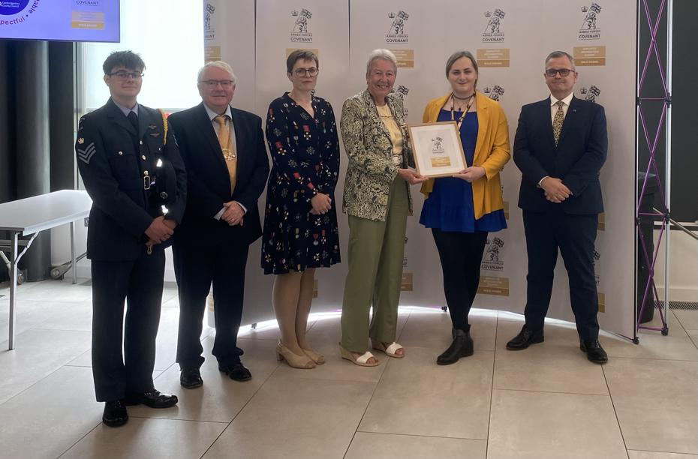From left to right: Cadet Flight Sergeant Logan Constable; Councillor Peter McDonald, Chair of Cambridgeshire County Council; Sarah Thompson, RFCA Defence Relationship Manager; Mrs Julie Spence OBE CStJ QPM, His Majesty’s Lord-Lieutenant of Cambridgeshire; Councillor Yannifer Malinowski, Armed Forces Covenant Champion, Cambridgeshire County Council; Dr Stephen Moir, Chief Executive of Cambridgeshire County Council.

Peter McDonald July 5th 2026

