WHITTLESFORD PARISH COUNCIL MEETING
HELD ON TUESDAY 14th APRIL 2026 AT 7.30PM
IN THE MILLENNIUM ROOM OF THE MEMORIAL HALL

MINUTES
All Members of Whittlesford Parish Council were summoned to attend for the following business to be transacted.

Present: Richard Williams, Philip James, Pam Freeman, Ian Beeby, Jan Holmes, Marc van Niekerk, David Cunado, Richard Redman, Felicity de Vries, Michael Kilpatrick and Emma Dunn, Parish Clerk Marie Swann, County Councillor Peter McDonald, and 4 members of the public.

ITEM 1. APOLOGIES FOR ABSENCE
No apologies for absence received.

ITEM 2. DECLARATION OF INTEREST
Richard Redman, David Cunado and Ian Beeby all declared an interest in item 8
ITEM 3. SIGNING OF THE MINUTES
The Minutes of Tuesday 10th March were signed as a true record.
ITEM 4. MATTERS ARISING
Annual Reports
Annual Reports were received from village clubs, groups and organisations.
All reports are to be submitted to the LOOK team for the May edition.
Tiger on demand bus stops
Whittlesford Parish Council submitted it nominated bus stops.
Parish Elections
All current Parish Councillors put themselves forward to stand again in the upcoming local elections of 7th May 2026. SCDC Monitoring Officer confirmed that Whittlesford Parish Council was uncontested and therefore a Parish Election is not required. All 11 Councillors signed the Acceptance of Office.
Dog Bins at Maynards
Following feedback from some of the residents in Maynards, the installation of the dog bin initially proposed for the open space will be paused whilst neighbouring residents are consulted about the location of the bin.

ITEM 5. ANNOUNCEMENTS FROM THE CHAIR
Greater Cambridge Development Corporation

Cllr Williams confirmed that the Council has submitted a response to the Government consultation on establishing a Development Corporation in Greater Cambridge. This would take decision making over planning away from South Cambs Council and give it to an unelected Government appointed body. The Parish Council strongly objected to the proposal.

Highways and Traffic.
Cllrs Beeby & Williams, with Cllr McDonald, met Highways recently to discuss options to address speeding at Hill Farm Road. Highways indicated that a 30mph zone on Hill Farm Road outside of the houses would be acceptable. The PC will explore making a bid for this later in the year.

Previously agreed applications to lengthen parking restricted hours on Station Road (East & West) and Royston Road and North Road are awaiting a response from the police (police consent is a condition of making an application). Cllr Williams is following up to move things forward. Options for improving safety at the Ledo Road/A505 junction are being discussed with County Highways.

Replacement ‘No Parking’ cones will be ordered for the Radegunds entrance on North Road

Duxford Road Walking/Cycling Path (East Side)
The County Council has come forward with slightly revised proposal for a walking/cycling path on the east side of Duxford Road between the central village and Station Road West. The Council did not feel that the revised plans addressed fast-moving safety issues, previously expressed by the council and corroborated by an independent safety audit, about visibility for residents turning out of driveways into the path of potentially fast moving cyclists; safety concerns around the slope of the path; and concerns about the configuration of the junction with Station Road West. The Council is very supportive of the principle of a new cycling path, but the current design is felt to be dangerous. We will engage with the County again asking for revisions that properly address safety concerns.

Parish Council’s response to the revised County proposals

Whittlesford Parish Council met to discuss its response to the revised County proposals on Tuesday 14th April. A number of residents of Duxford Road were present and spoke at the meeting.

The Parish Council is very supportive of improved cycling infrastructure in the village where schemes are well designed, safe and enjoy local support.

However, the Parish Council unanimously agreed that the revised scheme does not meet these criteria, and it therefore remains strongly opposed to the proposal.

The Parish Council’s concerns are:

- Inadequate visibility for residents exiting driveways int the path of potentially fast-moving bicycle traffic. Adequate visibility splays are not demonstrated given the reality of the area, and the path remains too close to driveways.

- Slope of the path. At several driveways the slope of proposed path would still exceed 2.5%, being 5% in many instances. This is double the recommended safe gradient. It is especially concerning that this left-right gradient occurs in places where the proposed path would be running downhill.
- Station Road West – Royston Road crossing. The revised proposal again fails to include a safe crossing to accommodate the ‘desire line’ path from Station Road West to Royston Road. This is a significant failing of the scheme.
- General concerns were again expressed by some Parish Councillors about the safety of dual use walking-cycling paths. Particularly in places like Duxford Road where there is little to no street lighting.
- The Parish Council remains of the view that the scheme is poorly thought through and badly designed and does not provide a realistic of safe route for cyclists travelling north from Moorefield Road towards the village.

We very much hope that we can work with the County Council on a significantly redesigned scheme that removes any new cycling facility from the verge adjacent to properties at the Station Road West end of the path.

The Parish Council has consulted with local schools who have indicated that they share our concerns about the safety of the proposed path. We also note that Cllr McDonald indicated to the meeting that he no longer supported the proposed scheme due to safety concerns.

The Old Guildhall original oil painting

An original oil painting titled The Blocked Drain at the Guildhall was offered to the Parish Council for public display. The Parish Council is to accept the oil painting and have it displayed at the Memorial Hall.

Land at Newton Road

Recent correspondence from the Solicitor dealing with the land at Newton Road raised search fees on an additional survey of the land. The survey will be approximately £300. The Parish Council have already agreed to pay the landowners fees of approx. £1,500. The Parish Council agreed to go ahead with the additional survey.

ITEM 6. OPEN FORUM
High Street
Following a request to replace the current litter bin outside the Shop and Post Office. The clerk will obtain a quotation for a replacement and larger litter bin.
A further request was to remove the old ice cream sign that was very weathered.
Street Lighting in the Village
Some residents have expressed concern about poor street lighting in parts of the village. There was general agreement on the Council that street lighting was poor and that we should look at whether increased lighting is possible – and what the cost would be. A full discussion will be held in June following further research.

Traffic Light System at the junction of the Guildhall
Concerns were raised over the 3-way traffic light system currently in place at the junction of the Guildhall corner at Church Lane, Duxford Road and the High Street. Cllr Williams and Cllr McDonald to follow up.
Fly-tipping at Middlemoor/Whippletree
Some bin bags and carpet had been reported as dumped in the woodland area at Middlemoor/Whippletree. Unfortunately, it is on private land and therefore SCDC will not remove it.
Pavement Resurfaced at Newton Road
A small stretch of pavement was finally repaired outside numbers 2 & 4 Newton Road. The small stretch of pavement was a trip hazard and was left in an unacceptable condition following the 2 new builds built back in 2018.

ITEM 7. COUNTY & DISTRICT REPORTS

Parish Council Report April 2026
Cambs County Council

Strategic Vision
Healthy, fair and sustainable – Cambridgeshire County Council’s bold new vision for the county launched 1st April, setting out a clear commitment to delivering real outcomes that enhance daily life for people across our county. Approved by Full Council in February, this new direction is informed by resident feedback gathered through the council’s annual Quality of Life survey.
This vision guides everything the Council does from today until 2028/2029: the decisions it makes, the services it delivers, and the partnerships it works with. It reflects our commitment to having a positive impact on everyone who lives, works and travels in Cambridgeshire, ensuring that the outcomes we deliver genuinely improve people’s lives and strengthen our communities. It will help ensure Cambridgeshire is well prepared for the changes and challenges to come including Local Government Reorganisation. The vision is supported by the Strategic Framework and its three key ambitions, which together provide a clear, consistent direction for the years ahead.

Below are the video and the strategic framework slides

https://youtu.be/sN9oDNwv7do?si=Uu4HuIKrwXcbnVL0

https://www.cambridgeshire.gov.uk/asset-library/business-plan-section-1-strategic-framework-2026-29.pdf

Highways
Cllr Alex Beckett has published a Substack on the pothole situation
https://notesfromalex.substack.com/p/why-are-the-roads-so-bad-right-now

The overall spending this coming year is as follows.
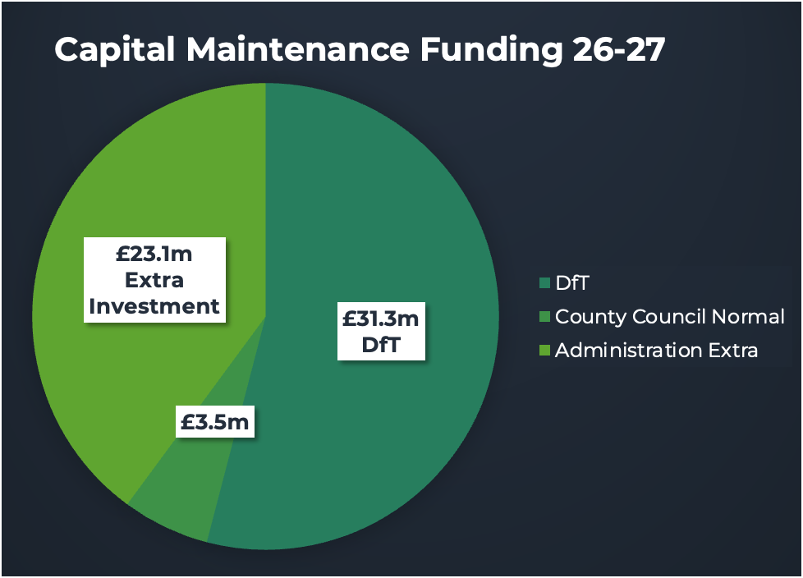

This is the pothole status in week 12 by area (S Cambs in Blue)
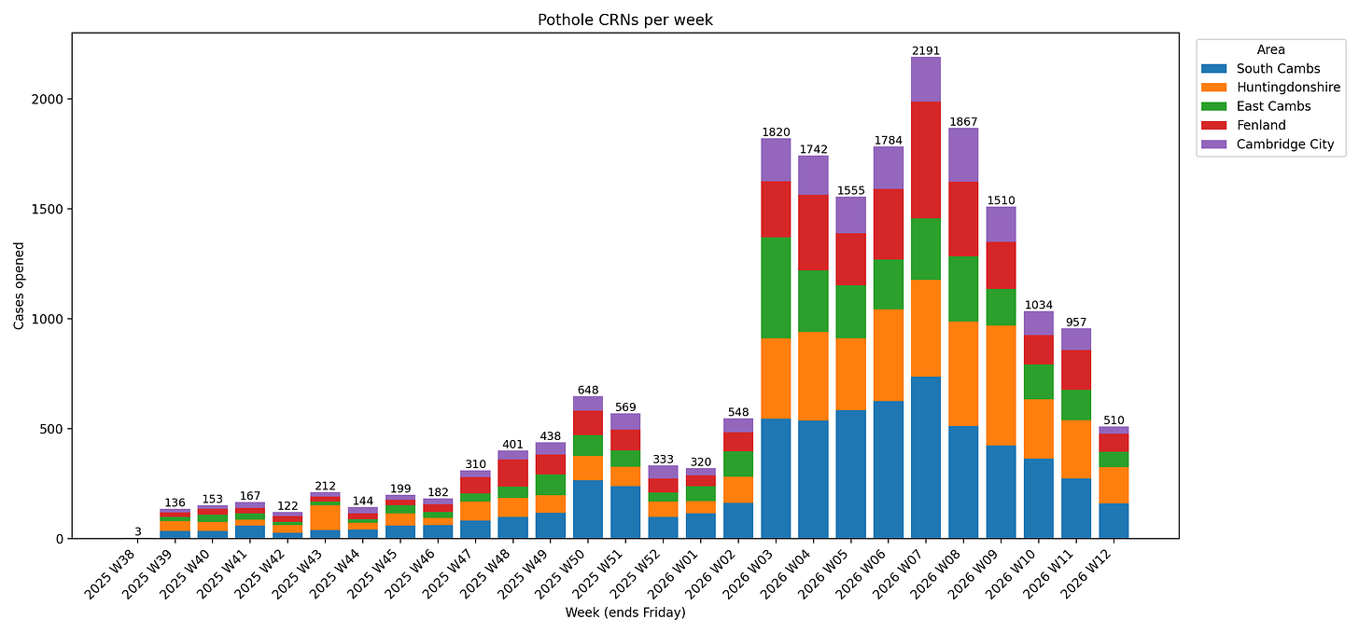

Heating Oil Support
Government funding has been made available for low-income families who heat their homes with oil to help tackle surging prices.

This targeted financial support, will help low-income households in rural communities who have no choice but to top up their tanks at a time when prices have risen so significantly.
Eligible households in Cambridgeshire can apply for a grant to support with these costs through the Cambridgeshire Community Foundation (CCF).
How to apply
- Apply online at Crisis & Resilience Fund: Cambridgeshire Community Foundation
- Residents can apply direct.
- Or by a referral organisation that has assessed your circumstances and can verify that you need of immediate assistance.
- All applicants will need to provide proof of address, income and the need to top-up with heating oil.
Who can apply
This fund is targeting Cambridgeshire households on low incomes who are reliant on heating oil and who need to top-up their tanks as a matter of urgency.
To receive this support, applicants must meet all of the following criteria:
- live in Cambridgeshire
- be reliant on heating oil to heat their home and/or water
- have 150 litres or less of oil remaining at the time of application
- be in receipt of or eligible for one of the following means-tested benefits:
  - Universal Credit
  - Pension Credit
  - Income based Employment and Support Allowance (ESA)
If funding allows, we hope to expand the scheme at a later date to households on incomes just above the threshold for means-tested benefits, or with exceptionally high energy needs.
Applications to the fund will open on Monday 30 March. In the meantime, please see our webpage Help with utility bills for other ways to access support.

Peter McDonald April 8th, 2026

District Report
Cllr Richard Williams
We are now in the pre-election period ahead of the District Council elections on 7th May. As is usual at this stage in the electoral cycle, the District Council has significantly reduced formal decision-making and public announcements. As a result, there is relatively little substantive new business to report over the past month.
That said, there have been a small number of important developments.

Greater Cambridge Development Corporation
The most significant issue over the past month has been the District Council’s response to the Government’s proposal to establish a centrally led Urban Development Corporation for Greater Cambridge.
An Extraordinary Meeting of the Council was held in March to agree the Council’s formal response to the consultation. The final position adopted by the Council was to clearly and unequivocally object to the Government’s proposals.
I proposed a series of amendments to the original draft response, which were accepted with cross-party support. These amendments significantly strengthened the Council’s position. In particular, they ensured that the Council’s response made clear its objection in principle to a centrally imposed Development Corporation, highlighted the democratic deficit that would arise from transferring planning powers away from locally elected councillors, and emphasised that the key barriers to growth in Greater Cambridge are national infrastructure and funding issues rather than failures of the local planning system. The amended response also raised concerns that the proposals risk undermining existing planned development rather than accelerating it.
As a result, the Council’s final submission clearly makes the case that growth in Greater Cambridge should continue to be led by locally accountable authorities working in partnership with Government, rather than through a centrally controlled body. I believe the strengthened response better reflects the concerns that many residents and communities have about these proposals.
In addition to the District Council’s formal response, I also submitted my own personal response to the Government’s consultation. In that response, I objected in principle to the creation of a centrally led Development Corporation for Greater Cambridge, reflecting my concerns about the loss of local democratic control and the risks associated with removing planning powers from locally elected councils.

Local Government Reorganisation

A public consultation on Local Government Reorganisation was open throughout March, giving residents the opportunity to comment on the different options for the future structure of local government in Cambridgeshire. South Cambridgeshire Council supported “Option B”, which would see Cambridge City and South Cambridgeshire combined into a single unitary authority, with the rest of Cambridgeshire forming a separate council. The decision now rests with Government, and we are likely to receive an indication of the preferred model over the summer. The current timetable still suggests elections to the new unitary authority taking place next year, although it remains to be seen whether this timetable will hold.

Weekly Food Waste Collections
The new weekly food waste collection service is now beginning to be rolled out locally. In Whittlesford, residents should have received their grey food waste bins this week. Weekly food waste collections are due to start from 11th May.
As previously reported, the introduction of this service represents a significant operational change for the District Council, requiring additional vehicles and staff, and there remain some wider questions about the long-term costs and delivery of the scheme.
ITEM 8. TO DISCUSS A REQUEST FROM THE LAWN TRUST COMMITTEE TO PURCHASE A NEW ROTARY MOWER

Whittlesford Parish Council received a request from the Lawn Trust to purchase a second-hand rotary mower that was 10 years old at the cost of £7,500.
The rotary mower was intended to be an additional mower alongside the current mower which is currently 8 years old and in good working order.
The Parish Council discussed the matter and felt that it was more of an opportunity that had arisen to purchase the second mower rather than something that was essentially required.
The Parish Council felt that it could not justify the expenditure of £7,500 on an additional mower.
The Parish Council would be happy to support the Lawn Trust when the current mower needs replacing, and proper budgeting can be made in advance.

ITEM 9. TO DISCUSS AND APPROVE A DONATION REQUEST FROM ECO WHITTLESFORD TOWARDS REFESHMENTS FOR THE RECENT LITTER PICK

Following a recent litter pick in March, Whittlesford Parish Council agreed to gift a £50 donation to Eco Whittlesford as a contribution to providing refreshments on the day.
Whittlesford Parish Council send thanks to the Eco Whittlesford group for organising the litter pick.

ITEM 10.TO DISCUSS AND APPROVE COSTINGS TO REPLACE DOG BIN AT VICARAGE LANE

The Parish Council approved the costing to replace the broken dog bin at Vicarage Lane. Costings are expected to be approx. £150.00. Clerk to go ahead with the purchase.

ITEM 11. PLANNING
Planning Reference: 26/01121/LBC
Proposal: Replacement garden walls to front & side elevations.
Site address: 7 High Street Whittlesford.
Whittlesford Parish Council supports this application.
Planning Reference: 26/01120/HFUL
Proposal: Replacement garden walls to front & side elevations.
Site address: 7 High Street Whittlesford.
Whittlesford Parish Council supports this application.

Planning reference: 26/00887/HFUL
Proposal: Single Storey Side and Rear Extensions.
Site address: 11 Scotts Gardens Whittlesford.
Whittlesford Parish Council supports this application.

Planning Reference: 26/00617/FUL
Proposal: Installation of accessible parking space, condenser units with associated pipework. Retrospective works for ramp and handrail to existing ramp.
Site address: Building 6 Imperial War Museum Royston Road Duxford.
Whittlesford Parish Council supports this application.

Planning Reference: 26/00618/LBC
Proposal: Installation of accessible parking space, condenser units with associated pipework. Retention works for ramp and handrail to existing ramp.
Site address: Building 6 Imperial War Museum Royston Road Duxford.
Whittlesford Parish Council supports this application.

Planning Reference: 26/00785/HFUL
Proposal: Single storey rear/side extension.
Site address: 34 Mill Lane Whittlesford.
Whittlesford Parish Council supports this application.

Planning Reference: 26/00674/HFUL
Proposal: Alterations to garage and link building with first floor side extension and single storey rear extensions, replacement of all existing windows.
Site address: 9 West End Whittlesford.
Whittlesford Parish Council supports this application.

Planning Reference: 26/0311/TTCA
Proposal: Pseudo acacia Robina - Remove and replace with a more suitable, non-invasive, native tree
Site address: 3 Church Lane Whittlesford.
Whittlesford Parish Council supports this application.

Planning Reference: 26/0264/TTCA
Proposal: G1: 11x Plane Trees - Re-pollard to previous points removing 3 meters to maintain in their current location
Site address: The Hamilton Kerr Institute Mill Lane Whittlesford.
Whittlesford Parish Council supports this application.
ITEM 12. ACCOUNTS (Month 1 of 2026/27 accounts)

Whittlesford Parish Council Accounts – Month 1 2026/27
ACCOUNTS TO PAY – 1st April 2026 – 14th April 2026

ACCOUNTS TO PAY
Barclays Banking Charges 9.70
SSE Street Lighting 97.06 Vat - £16.18
One.com NP Plan Website fee 7.19 Vat - £1.20
Parish Council Website Domain Renewal 14.40 Vat - £2.40
Royal Mail Postage Stamps 14.40
Employers & Employees’ Pension Contribution 187.43
Parish Clerk Salary 68 hours 1,236.33
Parish Clerk PAYE to HMRC 221.16
Maynards Open Space Maintenance 200.00
Allotments & Community Orchard 200.00
Parish Cemetery Maintenance No Invoice submitted
Accountibbleity 265.00
ICO.org Data protection fees 52.00
LOOK Magazine Annual Advertising 540.00
CAPALC Affiliation fees 643.56
Cheffins Farm Tenancy Agreement M Deller 900.00 Vat - £150.00
Cheffins Farm Tenancy Agreement J Arnold 900.00 Vat - £150.00
Eco Whittlesford Donation Litter Pick 50.00
TOTAL ACCOUNTS TO PAY £5,538.23

VAT for Month 1 2026/27 £319.78
NO ACCOUNTS RECEIVED

ITEM 13. CORRESPONDENCE
No other items of correspondence were raised for discussion other than matters already discussed and recorded in the minutes.

ITEM 14. DATE OF NEXT MEETING
The date of the next meeting will be on Tuesday 5th May 2026 – Finance meeting for the End of Year Accounts.
Tuesday 12th May – Annual Meeting of the Parish Council followed by the ordinary monthly meeting of the Parish Council.
Friday 22nd May – Annual Parish meeting.

End of ordinary meeting.

WHITTLESFORD PARISH COUNCIL
NOTICE OF SPECIAL MEETING
Tuesday 14th April 2026
(To be held after the conclusion of the ordinary Parish Council Meeting)

- To consider a proposal to admit Mr Arthur Greaves to be an Honorary Freeman of the Parish of Whittlesford under s.249(5) Local Government Act 1972.

Whittlesford discussed the proposal to admit Mr Arthur Greaves to be an Honorary Freeman of the Parish of Whittlesford under s.249(5) of the Local Government Act 1972.

All Councillors present agreed to the above proposal put forward by Councillor Richard Williams.

The Honorary Freeman of the Parish Certificate will be awarded to Arthur Greaves at the Annual Parish Meeting on the 22^{nd of} May.

End of Special meeting.

---------------------------------------------------------------------------------------------------------

Signed by Chair of meeting:

Cllr Richard Williams

Dated: Tuesday 12th May 2026

