WHITTLESFORD PARISH COUNCIL MEETING
HELD ON TUESDAY 11TH JUNE 2024 AT 7.30PM
IN THE MILLENNIUM ROOM OF THE MEMORIAL HALL
MINUTES
All Members of Whittlesford Parish Council were summoned to attend for the following business to be transacted.
PRESENT
Chair - Richard Williams, Vice Chair - Philip James, Pam Freeman, Felicity de Vries, Andy McPhee, Ian Beeby, Parish Clerk Marie Swann and 3 members of the public.
ITEM 1. APOLOGIES FOR ABSENCE
Apologies were received from Jan Holmes, David Cunado, Michael Kilpatrick, Marc van Niekerk, and Ellie Standen and County Councillor Peter McDonald.

ITEM 2. DECLARATION OF INTEREST
None.
ITEM 3. SIGNING OF THE MINUTES
Minutes of Parish Council Finance Meeting of 7th May, The Annual Meeting of the Parish Council of 14th May, and the Ordinary Meeting of the Parish Council of 14th May were all signed as a true record.
ITEM 4. MATTERS ARISING
Internal Audit of Accounts
An independent review of the Parish Council accounts has been completed and the accounts have been submitted to the external Auditor. Information on Public rights to view the accounts is available on the parish website under ‘Council Finance’.
New Standing Orders
The new set of Standing Orders adopted for the Council in May are available to view on the parish website under ‘Policies and Procedures’.

Trees at Scotts Gardens
Clerk reported that following correspondence to two residents of Scotts Gardens and the High Street, all trees had been attended to very promptly.

New Water Taps at Allotments
The installation of additional standpipes at the allotments has been delayed due unusually wet ground, but it is hoped that work will begin very soon.

ITEM 5. ANNOUNCEMENTS FROM THE CHAIR
There were No announcements from the Chair.
ITEM 6. BRIEF DISCUSSION FROM MOSIAC ARTIST REF: ARTS & HERITAGE PROJECT
Local mosaic artist Jim Anderson gave a brief presentation to the Council about his proposal for mosaic work under the Parish Councils Arts & Heritage project. Jim has identified a site for the mosaic at the Memorial Hall and would seek to involve the whole village in the project. The Parish Council thanked Jim for the presentation and looks forward to taking the project forward with as much involvement from the village as possible.

ITEM 7. OPEN FORUM
It was reported that the bench in the Millennium Wood was damaged. The Parish Council will agenda the item for the next meeting with a view to replace.
It was reported that several of the village speed monitors are again out of action. The Highway and Road Safety Committee will endeavour to rectify the matter.
It was reported that fruit trees in the Community Orchard had been cut last year by an unknown person. The Parish Council asks that members of the public do not cut the trees in the Community Orchard. The Council employs a tree surgeon to carry out pruning each year.
The ‘John Turner’ bench at the allotments will undergo some light maintenance
Concerns were raised about excessive noise during event at the Tickell Arms and regular parking problems on North Road. The Council will contact the owners of the Tickell to discuss the concerns raised.

ITEM 8. COUNTY & DISTRICT REPORTS
Parish County Council Report – June 2024.
Cambridgeshire County Report
The supermarket voucher scheme operated in last week’s term holiday for all eligible families in Cambridgeshire.
Cambridgeshire County Council is continuing to run the scheme in the May half term using the Household Support Fund from the Department for Work and Pensions, with additional funding provided by the council.
Eligible families will automatically be sent a £15 voucher via email or text on Saturday 25 May. Any children who become eligible up until the 31 May will also receive vouchers. The voucher can be used at a choice of supermarkets. All vouchers must be claimed by 3pm on Friday 5 July.
The voucher scheme has been a huge success since it was introduced and appreciated keenly by families struggling in the current financial climate.
A survey revealed that over 70 per cent of families said the vouchers had helped them cope with the rising cost of living. More than 50 per cent said the scheme had reduced the need for them to seek other sources of support in the school holidays such as food banks.
Over 46 per cent of those responding to the survey said the vouchers had helped them buy healthier food such as fruit and vegetables for their families.
In addition to the holiday voucher scheme, there is further support available in response to the cost of living, which can be found here: Support with the cost of living - Cambridgeshire County Council
Further information about the Holiday Voucher Scheme, including FAQs for parents, can be found here https://www.cambridgeshire.gov.uk/residents/children-and-families/schools-learning/help-with-school-learning-costs/cambridgeshire-holiday-voucher-scheme

Foxton/Fowlmere 26 Bus
You will be aware after a huge number of discussions a service is retained in the village. Cllr Hobro, myself and Cllr Susan van de Ven have communicated updates.
Melbourn Greenway update
Our questionnaire is on hold but will launch after July 4th.
Watercourse Mapping
There is a new tool on the County site to see who is responsible for water courses. This is becoming more important with high rainfall scenarios. https://www.cambridgeshire.gov.uk/business/planning-and-development/flood-and-water/watercourse-management
The watercourses are colour-coded depending on type/maintenance obligations and you can find out further information about each watercourse by clicking on them. The map includes the following details in Cambridgeshire:
- Ordinary Watercourses
- Awarded Watercourses
- Middle Level Commissioners (MLC) Adopted Watercourses
- Main Rivers
- Internal Drainage Board Boundaries
We know there will be some watercourses, particularly the smaller ones that aren't yet included on the map. Over time we plan to build on this, adding in additional information wherever we can. To this end, if there are watercourses within your local area that that meet the definition on the above webpage but aren't currently included in the map, please contact us and we can discuss if it would be possible to add them in.
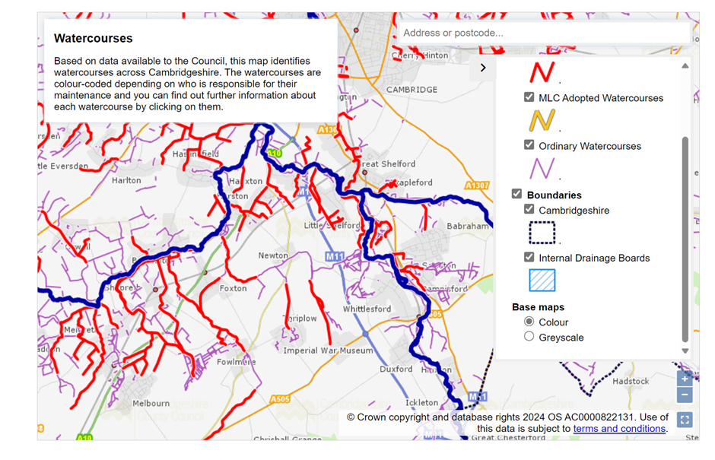
Peter McDonald June 2nd, 2024

There is No District Council Report this month.

ITEM 9. TREE FUNDING GRANT REQUEST
The Parish Council approved a small grant application from the village Tree Group to fund some additional Beech Trees along Duxford Road. The application was for £100 and will be paid under the small grant’s money set aside for village groups.

ITEM 10. TO DISCUSS AND APPROVE TRANSFER FEES RE: LAND AT NEWTON ROAD
A gift of land to the Parish Council has been offered in respect of part of the Newton Road Open Space (currently owned by third parties). The Parish Council agreed to accept the gift and authorised the payment of legal fees connected with the transfer for the transfer.

ITEM 11. TO DISCUSS ROSPA REPORT FOR THE NEWTON ROAD OPEN SPACE
The Newton Road Open Space recently had an annual RoSPA safety check on its play equipment. Clerk to summarise the report and arrange for the minor defects to be addressed.

ITEM 12. TO DISCUSS YELLOW LINES AT DUXFORD ROAD
The Parish Council discussed concerns that have been expressed by some residents about verge parking at Duxford Road, and the possibility of applying to extend the single yellow line parking restriction to cover an area where regular verge parking is taking place. Different views were expressed by Parish Councillors about the merits of extending the lines. It was agreed to explore the possibility of a short extension of the single yellow line to (or just beyond) the white village gates. A decision on whether to take the matter forward to a consultation with residents will be taken at a later meeting.

ITEM 13. PLANNING REPORT
- Planning Ref: 24/01669/HFUL
Site address: 5 Middlemoor Road Whittlesford
Proposal: Conversion of existing outbuilding to habitable space incidental to main dwelling, with associated alterations.
The Parish Council supported this application.
- Planning Ref: 24/01668/S73
Site address: 38 Station Road (West) Whittlesford
Proposal: S73 to vary condition 6 (Landscaping/biodiversity scheme) of planning permission 24/00370/S73 (S73 to vary conditions 2 (Approved plans) of planning permission 21/03980/FUL
The Parish Council will seek clarifications from the planning officer about the nature of the application.

- Planning Ref: 24/01624/HFUL
Site address: 84 Duxford Road Whittlesford
Proposal: Demolition of the existing single storey rear extension and erection of two storey side and rear extension with internal works.
The Parish Council supported this application.

- Planning Ref: 23/02780/CONDA – Information Only
Site address: 9 High Street Whittlesford
Proposal: Submission of details required by condition 3 (external materials) of planning permission 23/02780/HFUL

ITEM 14. ACCOUNTS – Month 3 (2024/25)
Whittlesford Parish Council Accounts – Month 3- 2024/25
ACCOUNTS TO PAY - 15th May 2024 – 11th June 2024

ACCOUNTS TO PAY
Barclays Business Banking Charges 13.40
SSE Street Lighting 21.13 Vat - £3.52
Employers Pension Contribution 127.43
Employees’ Pension Contribution 101.94
Land Registry Search NROS 18.00
Clerks Stationery HP Keyboard Mouse 29.21 Vat - £4.87
Petty Cash 200.00
Parish Clerk Salary 1,420.78
Parish Clerk PAYE to HMRC 288.78 Chq 100643
Parish Cemetery Maintenance 300.00 Chq 100644
Allotments & Community Orchard 200.00 Chq 100645
Maynards Open Space Maintenance 150.00 Chq 100645
Whitsers Playgroup APM Refreshments 125.65 Chq 100646
Glasdon Bins UK 2 x Dog waste bins (Lawn) 292.65 Vat - £48.77
Annual Accounts Internal Audit 391.50
MD Landscapes verge cut 550.00 Chq 100647
TOTAL ACCOUNTS TO PAY £4,230.45

VAT FOR MONTH 2 £57.16

ACCOUNTS RECEIVED
Resident Donation to the Community Fund 200.00
Resident Donation to the Community Fund 150.00
Unspent Petty Cash 200.00
Unspent Petty Cash 34.72
Land Registry refund 12.00
County Council Contribution Verge Maintenance 1,823.02
Barclays Loyalty Reward Interest 0.54
TOTAL ACCOUNTS RECEIVED £2,420.28

COMMUNITY FUND
Available Balance – 14th May 2024 £358.75
Resident Donations Received +350.00
Available Balance – 11th June 2024 £708.75

ITEM 15. CORRESPONDENCE
Email correspondence received from Whittlesford ECO Group was discussed.
The ECO Group were looking to plant some wildflowers in the far end piece of former allotment land at the Middlemoor Road end of the allotments.
It was agreed both the ECO Group, and the Environment and Open Space Committee should discuss further.

ITEM 16. DATE OF THE NEXT MEETING – Tuesday 9th July.

END OF PUBLIC MEETING

ITEM 17. EXCLUSION OF PRESS AND PUBLIC
The press and public may be excluded from the meeting during consideration of the following item in accordance with the provisions of Section 1(2) of the Public Bodies (Admission to Meetings) Act 1960 by reason of the confidential nature of the business to be transacted.

TO DISCUSS REVISED ESTIMATE RE: MEMORIAL HALL CAR PARK
This matter could not be discussed as the revised estimate had not been received.

Signed by Chair of Meeting:

Dated: 9th July 2024

