WHITTLESFORD PARISH COUNCIL MEETING
HELD ON TUESDAY 9th JANUARY 2024 AT 7.30PM
IN THE MILLENNIUM ROOM OF THE MEMORIAL HALL
MINUTES
All Members of Whittlesford Parish Council were summoned to attend for the following business to be transacted.
PRESENT
Chair - Richard Williams, Vice Chair - Philip James, Pam Freeman, Jan Holmes, Felicity de Vries, Michael Kilpatrick, Marc van Niekerk, David Cunado, Andy McPhee, Ian Beeby, Parish Clerk Marie Swann, County Councillor Peter McDonald and 1 member of the public.
ITEM 1. APOLOGIES FOR ABSENCE
Apologies were received from Ellie Standen.
ITEM 2. DECLARATION OF INTEREST
David Cunado and Andy McPhee both declared a close and notified neighbour interest in planning application at 97 Duxford Road. Neither took part in any discussion nor voted on the decision of the application.
Pam Freeman also declared a close and notified neighbour interest of planning application at 3 Royston Road and did not take part in any discussion or vote on the decision of the application.
ITEM 3. SIGNING OF THE MINUTES – 14th November 2023
The minutes of the parish council meeting of 14th November were signed as a true record. There was No meeting held in December 2023.
ITEM 4. MATTERS ARISING
None.
ITEM 5. ANNOUNCEMENTS FROM THE CHAIR
20 mph Zone in the Village
The County Council will be carrying out a consultation on the introduction of a 20mph zone in the central area village (West End, High Street, North Road, northern section of Duxford Road and all areas leading off these roads). The consultation is likely to take place in February or March and will be publicised by the County and through other local channels. The Parish Council discussed the proposal and agreed to seek further details on the consultation and to ask the County to write to all village households to publicise it.
Honour for Ken Winterbottom
The Chair reported that former councillor Ken Winterbottom has been awarded the British Empire Medal in the New Year’s Honours in recognition of his 44 years’ service on the Parish Council and for his work supporting village charities. The Parish Council sent its congratulations to Ken on this well-deserved recognition.

ITEM 6. OPEN FORUM
A litter problem has been reported at the site of the post box opposite IWM staff entrance. The District Council will be asked to undertake a litter pick in the area.
Increased and inconsiderate parking issues were reported on North Road throughout December.

ITEM 7. COUNTY & DISTRICT REPORTS
Cambridgeshire County Report to Parishes Jan 2024
County Council Budget
In December I reported that we were facing a £23m gap in funding for 2024/25 as a result of inflation and other factors. This has now been closed to c.£2m.
The revised proposals focus on sustaining social services, continuing to provide free school meal vouchers for eligible children during holidays, progressing the council’s commitment to pay the real living wage to people providing adult social care, and prioritising highways and cycleways maintenance across the county. However, even with a proposed council tax rise of 4.99% – 2% of which will be dedicated to adult social care services – the combination of demand for services, inflation and the ending of some government grants will still leave a £2m gap in the 2024/5 budget.
Included in the proposals for the coming year are for the council to:
- Invest £57 million to sustain children’s and adult social care services.
- Further the Council’s commitment to the Real Living Wage, which has increased to £12ph outside London, to take account of the Government uplift of the legally enforceable Living Wage, being paid by adult care providers.
- Prioritise £3m to continue to provide holiday food vouchers for all children eligible for free school meals, despite the government support being likely to end in the next financial year.
- Invest £2.2m to deliver other anti-poverty initiatives – such as support to make sure that vulnerable people are claiming all the welfare benefits that they are entitled to.
- Put £1.3m into delivering more accessible libraries to support vulnerable communities.
- Prioritise investment of £23m into making highways, footpaths, and cycleways safer – on top of a recently announced government allocation of £2.3m. This will be to deliver improvements which both repair and prevent potholes, deliver improved drainage schemes, and reinstate cycleway maintenance and weed clearance.
- Put additional funding into schemes for people experiencing mental health issues to prevent them reaching crisis, particularly focussing on younger people.
The proposals include an increase of council tax by 4.99%, the maximum permitted by Government before a public referendum is needed – with a total of 2% of this increase dedicated to adult social care services across the county, and £17.6m of identified additional savings – from areas such as:
- moving to LED streetlights which are set to deliver £1m in energy savings each year.
- £1.5m across the next three years from rationalising the council’s office accommodation.
- more than £2m from reviewing the highest cost children’s placement costs, and home to school transport routes – to bring children closer to home and reduce travel time.
- £0.5m from driving down the amount of bad debt.
- reviews of income raised by permits and parking charges are also proposed to raise just under £1m.
Summary of Changes in Finance 2024/25
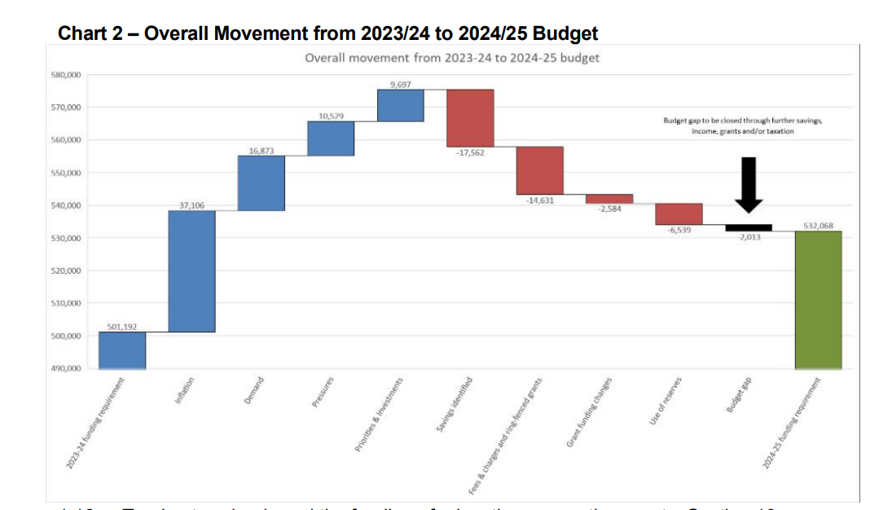
Flooding & Storm Henk
This were the incidents the county was attending to Jan 4th. It is updated daily and I will circulate every 2-3 days
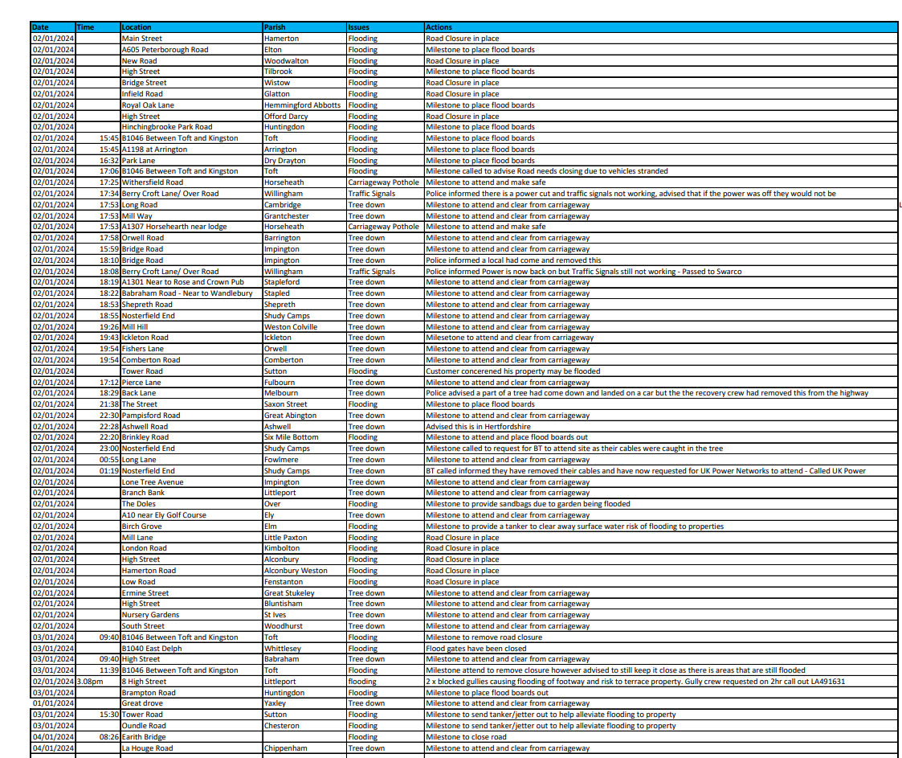
Peter McDonald Jan 7th 2024
Happy New year to all of You.

District Report
Cllr Richard Williams

Development in Greater Cambridge and Local Plan Update
In December the Secretary of State Michael Gove gave a speech which touched on development plans in Greater Cambridge. The SOs confirmed the Governments’ Cambridge 2040 strategy that had first been outlined in July 2023. The number of new houses at the heart of this strategy has dropped to 150K (from 250K) but there are not details on how or where such a number of new homes could be built. The SoS acknowledged the constraints that water supply put on development in the area but committed to finding solutions via the ‘Water Task Force’ established in summer 2023, again however, there were no details on what the solution would involve to increase supplies to a level that would enable anything like 150K new homes.
Separately, though with obvious links to the above, the Director of the Planning Service has given a recent update on the state of the next Local Plan. In short, Plan development is essentially on hold pending further details on solutions to the problem that restricted supplies of water currently place on housing and other development in our area. Concern that there is not enough water to meet current development plans has led the Environment Agency to object to several major developments in the last year, with most on hold as a result. There are plans for new reservoirs in the Fens and Lincolnshire, but these are unlikely to be operational before 2035. At present it is therefore not clear how ambitious plans for more houses and development in the area, from local or central government, can be met.
Report on Council Culture and Performance
A ‘Peer Challenge’ report on South Cambs council was published in December. The Peer Challenge system is organised by the Local Government Association and involves a group of councillors from other councils meeting Councillors and Council staff reporting on the culture and effectiveness of the organisation. The South Cambs Report contains a mix a praise and constructive criticism as is typical in these sort of report. You can read the full report here: https://www.scambs.gov.uk/your-council-and-democracy/2023-corporate-peer-challenge/
Civil Parking Enforcement Confirmed
The Government has confirmed that Civil Parking Enforcement powers have been introduced in South Cambridgeshire in mid-December. The County Council enforcement team will start issuing fined from February 2024 after an initial period of issuing warnings to illegally parked vehicles.

Clean Air Strategy
South Cambs Council and Cambridge City Council have agreed to develop a new Clean Air Strategy for our area. The strategy will link to the planning system – ‘with a focus on designing out air quality impacts during the construction of new developments. A further part of strategy will focus on transport and the provision of new sustainable travel options. The strategy will also include an information strategy on local air quality and an air quality monitoring network.

ITEM 8. TO DISCUSS AND CONFIRM DETAILS OF LHI TO BE SUBMITTED
Local Highways Initiative
The Parish Council discussed possible road safety schemes that could be proposed in the village for the County Council’s annual Local Highways Improvement scheme (where new schemes are joint funded with the County). The council considered five possible schemes that had been listed by the council Highways and road Safety Committee. By a majority vote the council decided to put forward a bid to introduce an 8am-6pm parking restriction on Station Road West and East and Royston Road to address anti-social parking problems raised by residents over many years. This would expand the current one-hour parking restriction which lasts between 11.30am to 12.30pm. Should the bid be successful, there would have to be a formal consultation of local residents before any changes were introduced.

ITEM 9. TO DISCUSS PROPOSAL OF A MOTION Ref: Planning.
Whittlesford Parish Council discussed the issues that often arise from a developer not restoring a footway or crossover on the highway following work such as extensions, refurbishment and building work carried out and believes it should be part of a standard planning process.
The following proposed motion was drafted by Councillor Kilpatrick.
The proposed motion will require further discussion from the parish council.
Motion relating to planning applications and maintenance of the Highway.
Whittlesford Parish Council notes that developments of or improvements to residential, business, or other properties represents an increase in the amenity and value of the site to the owners.
Whittlesford Parish Council notes the frequent damage to footways, verges, tracks and carriageways as a result of construction plant and vehicle movements relating to development works. Such damage is a consequence of the need for vehicles and construction machinery either to stop on or to traverse areas of the highways or other land in order to access the development site, whether by means of driveway, track, private road or other means, from the carriageway.
Whittlesford Parish Council believes that where works involve the use of machinery and/or vehicle movements, the beneficiaries must bear the cost of any reparations to the Highway as a result of the damage caused by such works.
The Parish Council calls on the Planning Authority to liaise with the Highways authority and to instigate a regime whereby:
- The condition of the highway at the entrance(s) of a site shall be recorded photographically prior to the commencement of any works.
- Np planning permission shall be granted by the Planning Authority without the submission of such photographic evidence unless it is evident the application shall not require vehicle or machinery movements.
- It shall as a matter of routine be a condition attached to planning permission that the highway (or other tracks or areas at the points of access to a site) shall be returned, at a minimum, to the condition as evidenced by the submitted photographs.
- Any reparations to the any part of the highway (or other land beyond the boundary of the site) shall be required to respect fully the material construction, levels, slopes, cambers and drainage needs in order to maintain pre-existing accessibility and usability.

ITEM 10. TO DISCUSS A REQUEST FOR GRANT FUNDING
The Parish Council received an application for grant funding from the Over 80’s Pilate Group who operate at the memorial hall and they were looking for approx. £240 for a sound system for their exercise regime.
It was agreed that the sound system would be purchased by the Memorial Hall and that it should remain at the Memorial Hall and that way it would be not only more convenient to have it stored there but it would be covered under the memorial hall insurance and if any other groups wished to use it, it would be available at the hall committee’s discretion.
It was agreed the applicant could liaise with the chair of the hall committee who would arrange the purchase.

ITEM 11. PLANNING REPORT
- Planning Ref: 23/0396/ LBC
Site address: 43 High Street Whittlesford
Proposal: Replacement windows to front.
- Planning Ref: 23/04254/HFUL
Site address: 3 Royston Road Whittlesford
Proposal: Addition of First Floor to existing single storey dwelling.
Amendment: The description has been amended to include front rear and side extensions.
The Parish Council had No Recommendation.

- Planning Ref: 23/04029/FUL & 23/04030/LBC
Site address: The Hamilton Kerr Institute Mill Lane Whittlesford
Proposal: Mechanical, Engineering and Plumbing services upgrade, including new ventilation to studios with new external vents, two new DX units and external lighting.
Amendment: Revised plans have been received to show the realignment of 3No. vents within the eastern elevation.
The Parish Council supported this application.
- Planning Ref: 23/04320/FUL
Site address: Provenance Kitchens Hill Farm Road Whittlesford
Proposal: Provision of electronic vehicle charging facility to include the provision of 1 no. sub-station, 1 no. feeder pillar, new vehicular access
and landscaping.
The Parish Council supported this application.
- Planning Ref: 23/04492/HFUL
Site address: 1 Bar Lane Cottages Newton Road Whittlesford
Proposal: Two storey rear extension, new porch, internal alterations, and associated works.
The Parish Council had No Recommendation.
- Planning Ref: 23/1439/TTCA S211 Tree Works Notice (conservation area) – Information Only.
Site address: 11 North Road Whittlesford
Proposal: T.1 Cotoneaster - Crown reduce by .5M to re shape
T.2 Honey locust - Crown lift to 3M from floor level
T.3 Silver Birch - Crown reduce height by 2M to allow more light to pool area and re shape.
T.4 Cedar - Crown lift by 2M from floor level and remove deadwood.
T.5 Greengage - Fell dead tree.
- Planning Ref: 23/03536/FUL
Site address: 105 Duxford Road Whittlesford
Proposal: Demolition of existing structures and erection of 2no 4-bedroom dwellings and 2no garages.
The Parish Council did not support this application as nothing had changed since the last application to change the minds of the council. Neighbour concerns had not been addressed.
- Planning Ref: 23/04605/FUL
Site address: Parade Ground, Duxford Airfield, Royston Road Duxford.
Proposal: Repair of tarmac hard standing surfacing of existing Parade Square, drainage, soft landscaping, and associated works.
The Parish Council supported this application.
- Planning Ref: 23/04730/HFUL
Site address: 46 Duxford Road Whittlesford
Proposal: Installation of an Air Source heat pump.
The Parish Council had No Recommendation other than any noise that may be generated from the heat pump.
- Planning Ref: 23/04691/HFUL
Site address: 2 Scotts Gardens Whittlesford
Proposal: Installation of an air source heat pump to the rear.
The Parish Council had No Recommendation other than any noise that may be generated from the heat pump.
- Planning Ref: 23/04813/HFUL
Site address: 97 Duxford Road Whittlesford
Proposal: Part two-part single-storey sides and rear extension with alterations to glazing and doors.
The Parish Council did not support this application due to inaccurate plans.
- Planning Ref: 23/04892/CL2PD – Information Only.
Site address: 16 Mill Lane Whittlesford
Proposal: Certificate of lawfulness under S192 for a Rear Dormer Loft Conversion and Replacement Windows.
ITEM 12. ACCOUNTS – Months 9 & 10.
Whittlesford Parish Council Accounts – Month 9
ACCOUNTS TO PAY - 14th November 2023 – 12th December 2023
The following accounts may have been amended/updated to reconcile with the end of year financial figures of income and expenditure.
Barclays Business Banking Charges 16.05
SSE Street Lighting 95.85 Vat - £6.36
Employers Pension Contribution 103.97
Employees’ Pension Contribution 83.18
Community Fund 150.00
Over payment cemetery fees PAS 475.00
Accountibbleity ref: quarterly payroll 105.00
Parish Clerk Salary 76 hrs 1,218.33
Parish Clerk PAYE to HMRC 176.33
Parish Cemetery Maintenance 200.00
Allotments & plot clearance 24a & b 300.00
Maynards Open Space Maintenance 150.00
TOTAL ACCOUNTS TO PAY £3,073.71
VAT FOR MONTH 9 £6.36
ACCOUNTS RECEIVED
Parish Cemetery burial fees ref: H25 & G34 950.00
Parish Cemetery burial fees 495.00
Ivett & Reed Headstone 300.00
Parish Cemetery memorial garden fees 125.00
Barclays Business Loyalty Reward 000.81
TOTAL OF ACCOUNTS RECEIVED £1,870.81
COMMUNITY FUND
Available Balance – 14th November 2023 £658.75
Accounts Paid – 12th December 2023 - 150.00
Available Balance 12th December 2023 £508.75

Whittlesford Parish Council Accounts – Month 10
ACCOUNTS TO PAY - 13th December 2023 – 9th January 2024.

The following accounts may have been amended/updated to reconcile with the end of year financial figures of income and expenditure.

Barclays Business Banking Charges 15.45
Employers Pension Contribution 93.03
Employees’ Pension Contribution 74.42
Community Fund 150.00
One.com NP Website Hosting 100.64 Vat £16.77
Clerks Stationery HP Printer Ink 74.92 Vat £12.49
Clerks Stationery HP Printer Paper 53.46 Vat £7.24
Parish Clerk Salary 40 hrs plus holiday 1,134.30
NROS Annual Maintenance 1,520.00 Chq 100614
Annual Hedge Cutting Maintenance 830.00 Chq 100614
Parish Clerk PAYE to HMRC 113.44 Chq 100615
Parish Cemetery Maintenance 200.00 Chq 100616
Allotments & Community Orchard 200.00 Chq 100617
Maynards Open Space Maintenance 150.00 Chq 100617
Cambridgeshire Acre Membership 65.00 Chq 100618

TOTAL ACCOUNTS TO PAY £4,774.66

VAT FOR MONTH 10 £36.50

ACCOUNTS RECEIVED
Parish Cemetery Memorial Garden Fees 250.00
Allotment Tenancy & Deposit 24B 71.75
Barclays Business Loyalty Reward 000.75
Interest from NS & I account 576.32
Allotment Rent 29.00
TOTAL OF ACCOUNTS RECEIVED £927.82

COMMUNITY FUND
Balance at 12/12/23 £508.75
Accounts to pay 24th December 2023 - 150.00
Available Balance 9th January 2024 £358.75

ITEM 13. CORRESPONDENCE
No correspondence was raised for discussion.

ITEM 14. STATEMENT OF ACCOUNTS
Clerk confirmed that Whittlesford Parish Council hold three accounts and Clerk provided all councillors with a statement of the available balances together with some info of what is held in which account. A hard copy of balances was also provided.
The Statement balance of each account is as follow:
- Barclays day to day account - £81,882.12 – 15th November 2023
This is the main account and is used for the day to day running of the parish council.

- Barclays Saver account - £37,324.67 – 15th November 2023
In October accounts the parish council paid all section 106 money held on behalf of the Lawn Trust, together with interest. Monies paid to the lawn trust were: £29,501.29 and interest of £175.65.
Balance remaining in the saver account was £10,000 which was set aside for LHI projects together with a small interest earned.
To this balance we have now added the £20,000 set aside for the Duxford Road footpath repair which was also held in our day-to-day account.
There is also a remaining balance of Section 106 money awarded from Welch’s Transport to be spent on Arts & Heritage which is currently £7,262.95.

- NS & I - £74,489.32 – 31st December 2022
Whittlesford Parish Council currently holds £74,489.32 in a National Savings & investment account.
Balance remains unchanged from end of year accounts - 31st March 2023.
It was agreed the Finance and General-Purpose Committee would meet to look at other potential accounts that would be easily accessible and offer a better rate of interest. Also agreed to speak with Paul from Accountibbleity for his advice on this.

ITEM 15. TO REVIEW SECTION 106 MONEY HELD
Apart from the NS & I account (details as above) which holds Section 106 money awarded from the Maynards development the only remaining 106 monies held is the balance from money awarded from Welch’s Transport which is currently £7,262.95.

ITEM 16. TO REVIEW PARISH CEMETERY FEES
Whittlesford Parish Council is a member of the Institute of Cemetery and Crematorium Management (known as ICCM) which provides both guidance and advise to burial authorities for an annual subscription of £95.00.
Our Cemetery fees are in keeping with our neighbouring parishes and reviewed annually. No changes were made, and it was agreed to carry out a further review in November 2024.
Our current fees are as follow:
WHITTLESFORD PARISH CEMETERY FEES

Whittlesford Parish Council, the Burial Authority for the Parish of Whittlesford and under the Local Authorities’ Cemeteries Order of 1977 set the following fees in connection with burials in
The Whittlesford Parish Cemetery as follow:

(Reviewed November 2023) Resident / Non-Resident
Grant of Exclusive Right of Burial – Adult £225/450
Grant of Exclusive Right of Burial – Child £125/250
Grant of Exclusive Right of Interment of Ashes £125/250
Interment in new or existing grave – Adult £250/£500
Interment in new or existing grave – Child No Charge
Interment of ashes in existing grave £100/£150
Interment of ashes in Memorial Garden £125/£250
Erection of plaque/tablet in Memorial Garden £125/£250
Erection of Grave Headstone £175/£350
Additional Inscription to existing Headstone £125/£250
Amendment to an Exclusive Right of Burial £25 Admin fee

ITEM 17. REVIEW OF ALLOTMENTS & FARM TENANCIES
- Income and expenditure of Allotments:
- The Parish Council currently has 59 chargeable plots in operation.
- Annual rent per plot was increased from £20.00 to £24.00 in October 2022.
- This has taken our annual income to an estimated £1,416.00. (excludes water charges). Water charges are £5.00 per plot and brings in approx. £270.00.
- Annual mains water charges for 2022/23 were £360.00.
- It was agreed that the shortfall should not be paid from the precept and the only option was to increase the annual water charge from £5 to £7. This increase will not take effect until the new allotment year beginning 1st October 2024.
- In light of various work that is required to be carried out at the allotments, it was agreed that no increase would be made to the current rent, but this will be reviewed at the next finance meeting.
- Annual maintenance costs of the allotments and the community orchard are £2,400.
- It was agreed the Allotment Committee would meet to discuss what budget was required for additional work to be carried out.

FARM TENANCIES
The Parish Council currently has 2 farm tenancies.
- Stonehill Field Hill Farm Road
One tenancy is for Stonehill Field, Hill Farm Road, and this gives an annual income to the parish council of £366.00. This is based on 3 acres of land @ £122 per acre.
This is paid in 2 equal payments of £183.00 in April and October each year.
Our tenant signed a 5-year business farm tenancy contract and therefore no further reviews are necessary until 2026.

- The Old Recreation Ground Vicarage Lane
Our second tenancy is for ‘the Old Recreation Ground’ at Vicarage Lane.
This is currently under review.

ITEM 18. TO REVIEW ALL EMPLOYMENT CONTRACTS, RATES OF PAY AND SET AND APPROVE NECESSARY BUDGETS.
- PARISH CLERK
The review of the Clerks pay scale was discussed at the end of the meeting (Clerk not present) Clerks pay scale to be increased by £1 per hour and in line with CAPALC.s regulations this is to be back dated to April 2023.
Chair to arrange an appraisal.

- MAYNARDS OPEN SPACE
Approx annual maintenance costs are £1,400.

- NEWTON ROAD OPEN SPACE
Approx maintenance costs are £1,500.

- VERGE MAINTENANCE & FOOTPATHS
Our grass verges and footpaths are maintained by MD Landscapes.
On average we have 3/4 cuts per year and each cut costs £500/£600.
The Parish Council receives an annual income of £1,823.02 from the Cambridgeshire County Council towards verge maintenance costs.

- PARISH CEMETERY
Approx maintenance costs are £3,000.
Approx income is £1,500 - £3,000.

- ALLOTMENTS & COMMUNITY ORCHARD
Approx maintenance costs of the allotments are £2,400.
Some of this maintenance is public footpath land.
An additional and on average £500 is paid on annual tree pruning and maintenance at the community orchard.
Approx income of allotment rent is £1,400.
Allotment committee to meet to discuss what work is required and to set a budget.

- COMMUNITY ALLOTMENT GROWERS GROUP
No Review taken place.

ITEM 19. TO REVIEW ANNUAL GRANT TO THE LAWN TRUST
Annual maintenance grant paid by the parish council to the lawn trust for general maintenance was reviewed at last year’s finance meeting and it was increased from £10,000 to £12.000.
A further review will be made in November 2024 subject to a receiving a copy of their end of year accounts.
ITEM 20. TO REVIEW THE PARISH WEBSITE
The parish website: www.whittleweb.org.uk
The Parish Council pays an annual subscription of £120 to Parish Council Websites who provide our domain address of Whittlesford.org (known as whittleweb). They also set up several of our whittlesford.org email addresses and run maintenance checks on the website as well as providing help with technical assistance and keeping us up to date with new legislation for parish council websites and ensuring we are fully compliant.
It was suggested that all councillors should consider using parish council email addresses. This is however optional and not compulsory.
It was agreed the Finance and General-Purpose Committee would meet to review the overall content of the website.
ITEM 21. TO REVIEW THE GRANT FUNDING POLICY AND BUDGET
Previous finance meeting the parish council approved a small grant funding policy and set aside a £5,000 budget. The policy came into effect in April 2023 at the start of the new financial year.
It was agreed to keep the policy and £5,000 budget in place.
Full details of the funding criteria and how to apply can be found on the parish website.
ITEM 22. TO REVIEW THE AGREED IN PRINCIPLE CONTRIBUTION TO SSYI
The Parish Council had previously agreed in principle a contribution of £2,500 to SSYI and this was to be followed up in terms of how we connect the teens in the village to be more aware of what the group provides and to join the group which operates in Great Shelford. It had come to our attention that there was a possibility of the group expanding its venue to the URC on a regular basis.
Chair to follow this up before the level of contribution was formally agreed.

ITEM 23. TO REVIEW BUDGETS AND APPROVE PRECEPT FOR 2024/25
Generally, an overall budget would be approved in order to confirm how much precept was required.
Some areas are specifically budgeted for, and other areas are calculated using the information from the end of year financial statement from our predicted and actual expenditure and used as a guide to what we think our income and expenditure are likely to be the following year.
The Parish Council has a few potential projects coming up in 2024/25 and some of this funding has already been set aside.
It was therefore agreed that the Finance and General-Purpose Committee would meet once all committees had finalised their individual budget requirements.
Moving forward into the new financial year of 2024/25 and taking into account of all estimated budgets, potential grant projects and contributions agreed in principle together with our estimated figures we expect to close the current financial year at, it was agreed to make no changes to the current precept, and this would remain at £70,000.00.
The decision to keep the precept at £70,000.00 (Seventy Thousand Pounds) for the financial year of 2024/25 was proposed by Philip James and seconded by Marc van Niekerk.

ITEM 24. DATE OF NEXT PARISH COUNCIL MEETING
The date of the next Parish Council meeting is Tuesday 13th February 2024.
The APM date was confirmed as Friday 17th May 2024.

ITEM 25. DATE OF NEXT FINANCE MEETINGS
The dates of 2024 Finance meetings were confirmed as:
Tuesday 7th May 2024 - End of Year Accounts
Tuesday 3rd December 2024 – Precept & Budgeting

ITEM 26. TO CONFIRM ALL OTHER ‘MEETING DATES’ FOR 2024
JANUARY Tuesday 9th January 2024 – Parish Council Meeting
FEBRUARY Tuesday 13th February 2024 – Parish Council Meeting
MARCH Tuesday 12th March 2024 – Parish Council Meeting
APRIL Tuesday 9th April 2024 – Parish Council Meeting
MAY Tuesday 14th May 2024 – Parish Council Annual Meeting
Friday 17th May 2024 – Annual Parish Meeting
JUNE Tuesday 11th June 2024 – Parish Council Meeting
JULY Tuesday 9th July 2024– Parish Council Meeting
AUGUST No Meeting held in August.
SEPTEMBER Tuesday 10th September 2024 – Parish Council Meeting
OCTOBER Tuesday 8th October 2024 – Parish Council Meeting
NOVEMBER Tuesday 12th November 2024 – Parish Council Meeting
DECEMBER Tuesday 10th December 2024 – Parish Council Meeting

Meeting closed at 9.45pm.

Signed by Chair of Meeting:

Dated: 13th February 2024.

