WHITTLESFORD PARISH COUNCIL
MINUTES
OF PARISH COUNCIL MEETING HELD ON TUESDAY 8th FEBRUARY 2022
IN THE MILLENNIUM ROOM OF THE MEMORIAL HALL AT 7.30PM

PRESENT : Chairman Arthur Greaves, Vice Chairman Tim Teversham, Pam Freeman, Ken Winterbottom, Phillip James, Michael Kilpatrick, Parish & District Councillor Richard Williams, County Councillor Peter McDonald, Parish Clerk Marie Swann & 7 members of the public.
ITEM 1. APOLOGIES FOR ABSENCE
Apologies were received from Jan Holmes, Felicity de Vries and Marc van Niekerk.
ITEM 2. DECLARATION OF INTEREST
None.
ITEM 3. SIGNING OF THE MINUTES
The minutes of parish council meeting held on Tuesday 11th January 2022 were signed by acting Chairman of that meeting Tim Teversham as a true record.
ITEM 4. MATTERS ARISING
Councillor Richard Williams gave an update on the recent LHI presentation for Hill Farm Road. Richard met with Highways Engineer James Toombs to discuss the feasibility of traffic calming proposals prior to the presentation. If the presentation was successful we will be notified in due course.
ITEM 5. OPEN FORUM
Clerk received 4 items of correspondence from members of the public in relation to Open Forum.
- Concerns over an incident at the junction of the High Street / North Road / Duxford Road involving a cyclist and a vehicle. Concerns were raised of the safety of the junction and what likely improvements could be made.
Councillor Richard Williams aimed to follow up the incident by contacting local police for an incident report to try and establish what actually happened and despite reports to say that the cyclist attended A & E unfortunately the police had no record of any such incident. No one has come forward to give any factual evidence or report to the parish council and it is very difficult to take something forward without any facts, figures or data. Many traffic calming suggestions have been put forward in the past by the parish council but all have been rejected by county highways.
Chairman agreed to take the matter forward and discuss the safety concerns of the junction as an agenda item in March.
- Email correspondence was also received in relation to how the Parish Council communicates with its parishioners. A member of the public has asked that its social media communication channel be reviewed.
Chairman agreed to take the matter forward to an agenda item in March.
- Email correspondence received of all speed monitors out of action. Councillor Michael Kilpatrick to change the batteries. It was suggested that the parish council shares the responsibility of the maintenance of the monitors. Councillor Richard Williams and Councillor Philip James both offered to share the maintenance so it does not fall on one councillor alone.
- Clerk received a call from a parishioner asking for the turning point at the bottom of Church Lane to be reinstated as white lining had worn away and vehicles were being parked there not knowing that it is a turning point and not a parking area.
County Councillor Peter McDonald will follow it up with Highways John O’Brien and the resident will be kept informed.

Other items raised in ‘Open Forum’
It was reported that several wheelie bins had disappeared from outside properties in North Road and left abandoned. Green bin garden waste had been emptied onto the road and footpath. The incident happened around 10pm on Sunday evening 6th February. Some green bins were reported as being found in the Shelford Road layby.
An increase in graffiti was also raised. Graffiti has been found mainly in bus shelters and over litter bins.
Water main renewal began at Hill Farm Road on Monday 7th February and reports have already been made regarding wrong signage as to access to the A505. County Councillor Peter McDonald to follow up reports. A representative of A to B bus company was present to clarify their position in relation to reports of buses not arriving / late arriving due to the diversions in place at Hill Farm Road.
A parishioner wished to raise the matter of the GCP ‘Rural Travel Hub’ as it was felt that a great deal of money had already been spent but no information has been released lately.
District Councillor Richard Williams to follow up the question raised.

ITEM 6. TO APPROVE THE ADDITION OF ‘VILLAGE DIARY DATES’ TO THE WEBSITE
All Councillors present were happy to add a Village diary and events page to the parish website. It will be the responsibility of clubs and societies to forward the dates and information to the Clerk.

ITEM 7. TO DISCUSS AND APPROVE AN AMENDMENT TO THE STANDING ORDERS OF HOW ‘OPEN FORUM’ IS CONDUCTED
The Parish Council discussed ways to improve and facilitate its ‘Open Forum’
Very often there can be several ‘Open Forum’ questions put to the Parish Council by members of the public present at a meeting and together will email correspondence, open forum can be a lengthy agenda item.
Whilst the Parish Council would like to encourage its Parishioners to be more actively involved in what the parish council do, they should be reminded that ‘Open Forum’ should be kept to simple and straight forward questions and answers and not become a lengthy discussion or debate. We realise it is not always possible for some parishioners to attend a monthly meeting but they may still have a question to put forward. The Parish Council would therefore like to encourage parishioners to submit their question or concern to the Clerk prior to our monthly meeting by email or letter.
The Parish Council makes the following amendment :

WHITTLESFORD PARISH COUNCIL
AMENDMENT TO STANDING ORDER – ‘OPEN FORUM’

In order to facilitate the efficient running of Parish Council meetings, Whittlesford Parish Council hereby makes the following amendments to its Standing Orders in relation to ‘Open Forum’

1. Parishioners should be encouraged to submit in writing (including email), and at least 2 days prior to a parish council meeting the topic/question he or she would like to ask/discuss. This will enable the Councillors to prepare answers hopefully to the satisfaction of the questioner.

2. At the discretion of the Chairman ‘Open Forum’ may be restricted to a maximum time of 30 minutes with a 5 minute time limitation, for presentation and discussion of each question/topic.
Open Forum should be simple questions and answers and not a debate.

3. Priority will be given to correspondence received in advance.
Parishioners will then be entitled to ask only one question until the Council has heard from all parishioners wishing to pose a first question.
Parishioners may be able to pose further questions/topics up to the previously mentioned limitations.

4. No decision/resolution can be made on any question/topic brought up in ‘Open Forum’ if there is a financial implication as such financial decisions cannot be made unless the matter is an agenda item. If the matter has not been satisfactorily resolved at the end of the time limitation no further discussion will be allowed and
such matters may be tabled as an Agenda item for discussion at the next meeting of the Parish Council.

The above amendments were discussed and approved by all councillors present at meeting held on Tuesday 8th February 2022.
The amendments will take effect at the next meeting of 8th March.

ITEM 8. TO DISCUSS THE UPCOMING PARISH ELECTIONS
Both Parish and District Elections are due to take place on Thursday 5th May 2022. All Councillors present were given a nomination paper to complete and return to the Clerk at the next meeting of Tuesday 8th March. It is not yet certain if Parish Elections will be contested until all nomination papers have been received by the Elections Officer. Deadline for nomination entries is 4th April. The Parish Council awaits further guidance from South Cambs on Public Notices which are to be displayed and any members of the public who are not currently a Councillor may put themselves forward for election by contacting the Parish Clerk or the Elections Officer at South Cambs for a nomination paper. Alternatively all information required is available on the SCDC website at www.scambs.gov.uk Elections 2022.

ITEM 9. NEW BANK SIGNATORY TO SIGN FOR NS & I ACCOUNT
Councillor Richard Williams will replace Ken Winterbottom as cheque signatory on both parish council held accounts. The NS & I account form was signed at the meeting of 8th February and Clerk is to arrange an appointment with Barclays Bank for a change of signatory with the day to day Barclays account.

ITEM 10. PLANNING REPORT (The following applications were discussed)
Planning Ref : 21/05615/HFUL – 34 Station Road (West) Resubmission of Planning Ref : 21/04533/HFUL – Ground floor and first floor extensions to create a two storey dwelling house and erection of detached garage.
The Parish Council had No Recommendation.

Planning Ref : TPO 0010 (2022) – 38 Station Road (West)
The Parish Council were notified that the above application had been refused on the grounds of TPO’s.

Planning Ref : 22/00104/HFUL – 21 Ledo Road – Garage Conversion with raised roof, rear dormer and raised balcony.
The Parish Council did not support this application on the grounds of possible overlooking to neighbouring properties should a raised balcony be allowed.

Planning Ref : 21/05047/FUL – Wells Farm Shelford Road – Amendment (Info Only).

Planning Ref : 21/02448/NMA1 – 5 Duxford Road – Non Material Amendment in relation to a side ‘high up’ window that would not be able to be looked through due to the height.

ITEM 11. DISTRICT & COUNTY REPORTS

District Report from Cllr Richard Williams
February 2022

Civil Parking
On 7th February South Cambs gave its formal support for the introduction of Civil Parking Enforcement (CPE) in the District . The application for legal powers will be made to the Secretary of State by the County Council. The scheme in South Cambs is being financially supported by the GCP for the first five years. Enforcement will be ‘demand led’ in the sense that officers will be dispatched to places where problems arise. A public reporting tool has been promised. The timeline for the introduction of CPE was that it is ‘likley’ to come into force in 2023.

No Appeal Against Retirement Village Decision
South Cambs has stated that it will not be appealing the Planning Inspector’s recent decision to grant approval for a retirement village between Haverhill Road and Hinton Way in Stapleford. The application for development of the Green Belt site was opposed by local parish councils and was refused by the District planning committee in April 2021. A matter of planning balance, the planning inspector felt that need for retirement accommodation and the provision of a nature reserve outweighed the significant harm to the Green Belt from the development. The district planning committee felt strongly that the harm was not outweighed However, it is very disappointing that the Council is not prepared to defend the Green Belt by appealing the inspector’s decision.

Scrap Yard
A decision on the Scrap Yard Planning applications is likely in March.
New Biodiversity Planning Document.
South Cambs together with the City Council has approved new planning guidance about how developments must better protect and enhance biodiversity.
The ‘Supplementary Planning Document’ (SPD) is a technical planning guidance document which carries weight in planning decisions. Key requirements in the SPD are that:
- 100% of all new homes will require an integrated nest box for species such as swifts;
- 25% of new homes on housing developments will need to include bat boxes;
- Fences will need to feature gaps for hedgehogs and other species to roam more freely;
- Green roofs are encouraged, to create valuable habitats of flowering plants and grasses for wildlife in urban settings;
- Artificial lighting which harms nocturnal species in their habitats, woodland edges, hedgerows and wetlands must be reduced.
Northstowe
Outline planning permission was granted for a further 4,000 homes at Northstowe by an 8-3 vote of the District planning committee. Concerns about the development concentrated on the impact on the local environment from a projected 2-3m drop in the water table from the development (there have been well document problems of ponds drying up in Longstanton and reports of subsidence resulting from falls in the water table from previous developments); concern about flooding from the increased pressure on the Uttons Drove Sewerage works at Swavesey and the proximity of the new town to Oakington (just 40 m at the closest point).
Chalk Steams
The Combined Authority has approved funding for projects to support the regions calk streams. Our chalk steams are a rare and internationally significant for the habitats that they provide. Increasing pumping of water from the chalk aquifer to provide for the region’s growth have put chalk streams under pressure. Projects and funding to support chalk streams are therefore very welcome. However, continued pressure for high growth will put more and more strain on the local natural environment. There is a pressing need to repair damage already done to chalk steams (as recognised in the recent Stantec report for the local plan) and anything over minimum growth is not sustainable on current resources. To meaningfully protect and restore our chalk streams, my view is that we need to address the root cause of the problem as well as fund specific projects.
Cllr.williamsR@scambs.gov.uk/07584037016
Report for Parish Councils – February 2022.
South Cambs District Council
Council Tax
It is proposed to increase the S Cambs element by £5 to £160 for a band D property so a rise of 3.4%. The 3 year plan includes savings of c £1.5m over the next 3 years. This is the link to the 5 yr plan including this year’s C Tax.
https://scambs.moderngov.co.uk/documents/s125779/Summary%20General%20Fund%20Revenue%20Budget%202022-2023%20-%20Report%20for%20Cabinet.pdf

Civil Parking Enforcement

The next stage of the CPE programme is in progress at S Cambs and the funding available from GCP. https://scambs.moderngov.co.uk/documents/s125697/Civil%20Parking%20Enforcement%20in%20South%20Cambridgeshire%20-%20Report%20for%20Cabinet.pdf

Business grants update: Hospitality and Leisure Grant and Additional Restrictions Grant (ARG) top-up. This is up and running and the status as of January 28th was:

Omicron Hospitality & Leisure Grants
- Applications received:205
- Applications processed: 80
- Processed value: £280.6k (£128k actually pay out)
ARG
- Applications received: 62
- Applications processed:13
- Process value: £60k
- Rejected 7
- Pending/in progress 42

Cambridgeshire County Report

Current Covid & Vaccination Status Locally
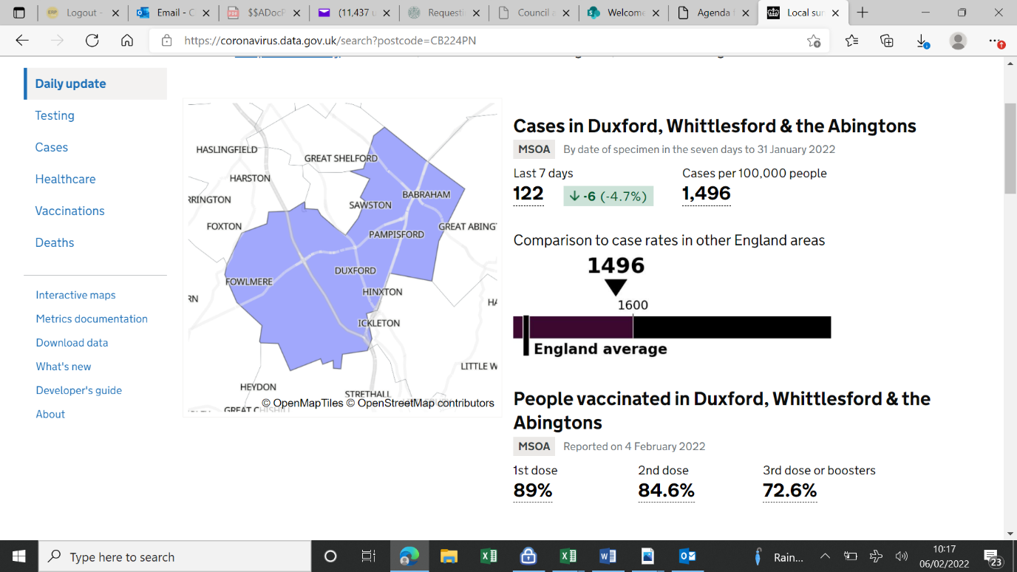

Cambridgeshire County Council Budget

The Joint Administration is to proposing a 4.99% rise in order to close the authority’s £16m budget gap this year. Next year’s funding gap is likely to be even worse. 4.99% would mean an extra charge of £1.04 per week for a Band B, and £1.19 for a Band C household. More than half of all homes in Cambridgeshire are in these two bands. Local government experts who visited in summer highlighted that historic decisions not to raise council tax in previous years had led to significant ongoing lost income to support services. The council is also proposing to set up and spend a £14m fund over the next five years to tackle inequality, improve lives and care for the environment.

In its first year, if agreed, the Just Transition fund will fund schemes that increase flood prevention in the county, continuing a recent rapid increase in gully clearing. It will also work towards tackling climate change; widen opportunities for children with special educational needs and disabilities; increase independent living services and expand direct payments and individual service funds – where adults assessed as needing support can choose and manage their own care services; and Expand the ‘Care Together’ programme, providing care services close to where people live.

Fire Authority Budget

Cambridgeshire and Peterborough Fire Authority is asking residents to have their say on proposals to increase the fire service’s share of council tax for 2022/23. The Service is looking for a below inflation increase of £1.44 (around 2%) for the year, making the total contribution for the year £74.97 for a resident living in a Band D property.

Following the financial settlement confirmed by the government at the end of December 2021, which confirmed the level of funding for the next year, the Service has reviewed its financial position, making savings where possible, and has considered what it needs to maintain its valued services to the public.

Police Budget
Police funding comes from two main sources: 56% from central government (excluding specific grants) and the remainder from the policing part of council tax.

In line with government guidance, the PCC is asking for people’s views on his proposed increase of £10 per year (83p per month based on a Band D property). This, together with an increase of £4.8m from government (excluding specific grants), would enable the Chief Constable to further maintain, invest and support in three key areas. Proposals are here: https://www.cambridgeshire-pcc.gov.uk/commissioner-proposes-precept-increase-to-support-record-officer-numbers-for-cambridgeshire-and-peterborough/

Thakeham

Local Parish Council representatives attended a virtual meeting with the Head of Greater Cambridge Shared Planning, Stephen Kelly, last week for an update on the Local Plan and OxCam Arc in relation to Thakeham’s ‘Southwest Cambridge’ affected villages.

Thanks to all who responded to the Greater Cambridge Local Plan First Proposals, which make it clear that Thakeham’s vision for 25,000 homes in and around our villages is simply not compatible with the principles of sustainable development. Thakeham’s only route is via top central government channels where power exists to override local democracy.

Health and social care reforms juggling act

A major reorganization of health and social care is happening now, with legislation in the process of passing through Parliament. This sounds heavy! Is it important? We think it impacts on us all.

The reforms include raising money through the National Insurance contributions that working people pay; widening eligibility for County-funded social care from about 4% of the population now to an estimated 14%, in Cambridgeshire (which must be paid for of course); and requiring the local NHS (our local GPSs, hospitals, etc) and the Local Public Health and Social Care Authority (Cambridgeshire County Council) to collaborate and integrate, and think at a ‘neighbourhood’ level. Prevention is a constant theme – how can we live better and avoid getting sick in the first place? How can we give children - from birth - the best chance of a healthy life? What more can local communities be doing to play a part?

Some of the principles seem overwhelmingly positive but other aspects of the reforms are daunting. These are huge bureaucracies and whatever new money is raised will be directed first to the enormous Covid-induced waiting lists. That will take time to work through.

Nevertheless, from July this year it will be a legal requirement for ‘Integrated Care Systems’ to be up and running with the basics in place. This means that all of these organisations, already working to deliver vaccinations, tackle waiting lists and attract new staff to a depleting workforce, also need to find time to reflect and prepare for new obligations under the Health and Care Bill.

Given that this new legal requirement involves local government, we’ve been learning fast and furiously. Our colleague Susan van de Ven is chairing the ‘Cambridgeshire Health and Wellbeing Board’ where the NHS and Local Authorities formally come together. If you’d like to know a little bit more, or if you can teach us a thing or two through your own experience and expertise, please join us for a Zoom coffee and chat on March 9th, 6-7PM – just let us know your contact details and we’ll send you the link.

20’s Plenty

Progress on introducing new 20mph speed limits to improve transport safety in Cambridgeshire was discussed at the Highways and Transport Committee on Jan 25th. The Council is looking to establish a new process for the implementation of 20mph schemes. This would allow third parties – such as Parish Councils - to make an application for a 20mph limit in their chosen area, with a number of schemes then progressing following a period of assessment and prioritisation.

There are two types of 20mph schemes which can introduced by the council – 20mph limits and 20mph zones. A 20mph limit typically covers individual or a small numbers of streets and requires signs only, while 20mph zones typically cover larger areas and require both signs and markings.

The former are more cost effective, but the latter have been found to have a greater impact in reducing speed limits, especially when accompanied by traffic calming measures. It is anticipated that details outlining how applications for 20mph schemes will be prioritised, once submitted, will be brought to a committee meeting later this year.

Civil Parking Enforcement
By the time you read this South Cambs DC will have written to the County Council to ask them to submit an application to the Department of Transport asking them to approve Civil Parking Enforcement for all of South Cambs. The police will no longer be responsible for enforcing illegal parking but instead Enforcement Officers employed by the County Council will be. The plan is to have two officers active full time moving between the villages and issuing parking fines to people who park where they should not. The agreement of the Greater Cambridge Partnership to underwrite the first five years costs has made it possible which is extremely good news. The less good news is that the wheels of government move slowly so we don’t expect it to be implemented until 2023.

Changes to the Highways Code
You will be aware of changes to the code from January 29th
https://www.gov.uk/government/news/the-highway-code-8-changes-you-need-to-know-from-29-january-2022

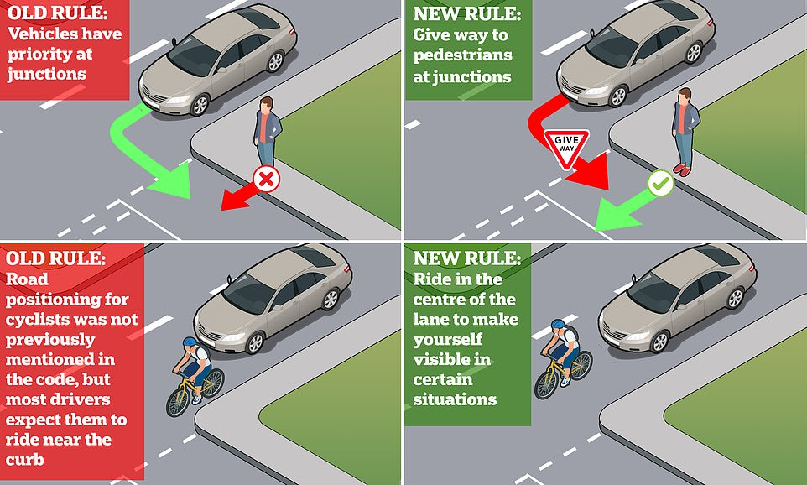
Peter McDonald
February 6th 2022

ITEM 12. ACCOUNTS
WHITTLESFORD PARISH COUNCIL
ACCOUNTS (12th January 2022 – 8th February 2022) Month 11

The following accounts were approved

ACCOUNTS TO PAY
Drax Energy (Street lighting) 1,226.13 (Vat unknown)
Peoples Pension (Employers Contribution) 86.12
Peoples Pension (Employees Contribution) 153.83
Barclays Business Banking Charges (Out) 14.65
Clerks Expenses (Paper,Envelopes & Ink) 65.96 (Vat - £10.99)
Parish Cemetery Contract (7 hrs) 140.00 Chq 100425
Maynards Open Space (6 hrs) 120.00 Chq 100426
Allotments & Community Orchard (8 hrs) 160.00 Chq 100426
Parish Clerk Salary (64 hours) 996.78 Chq 100427
Parish Clerk PAYE to HMRC 76.17 Chq 100428
Harefield Nurseries (Tree Parish Cemetery) 75.00 Chq 100429
Zero Carbon Tree Project (Vat - £11.67) 69.99 Chq 100430
Whittlesford PCC (Marquee Hire) 2,468.28 Chq 100431

TOTAL ACCOUNTS TO PAY £5,652.91

TOTAL VAT FOR MONTH 10 £22.66

ACCOUNTS RECEIVED
Cambridgeshire County Council
(Re imbursement for padlock (Baulks Gate) £39.99
Allotment Rent £55.00
TOTAL ACCOUNTS RECEIVED £94.99

COMMUNITY FUND REPORT
Balance at close of last meeting (11th January 2022) £706.65
Accounts to pay (12th January – 8th February 2022) --------

AVAILABLE BALANCE £706.65

ZERO CARBON GRANT REPORT
Balance at close of last meeting (11th January 2022) £1,830.62
Accounts to pay (12th January – 8th February 2022) 144.99
AVAILABLE BALANCE £1,685.63

ITEM 13. CORRESPONDENCE
No items were discussed

ITEM 14. DATE OF NEXT MEETING
The date of the next meeting of the Parish Council was confirmed as Tuesday 8th March 2022.

