WHITTLESFORD PARISH COUNCIL
MINUTES
OF ZOOM MEETING HELD ON TUESDAY 13th APRIL 2021

PRESENT
Chairman Arthur Greaves, Ken Winterbottom, Pam Freeman, Jan Holmes, Michael Kilpatrick, Will Thomas, Felicity de Vries, Philip James, District Councillor Richard Williams, County Councillor Peter McDonald, Parish Clerk Marie Swann, and 6 members of the public.
ITEM 1. APOLOGIES FOR ABSENCE
Apologies were received from Tim Teversham
No apologies were received from Ken Macdonald
ITEM 2. DECLARATION OF INTEREST
None
ITEM 3. SIGNING OF THE MINUTES
The minutes of parish council meeting held on Tuesday 9th March were signed as a true record
ITEM 4. MATTERS ARISING
We were notified that we had not been successful in our recent LHI bid for the footpath at Moorfield Road, however further discussion is underway in the hope that the path can go ahead and still be funded by the county.
A new dog bin was purchased, and installed close to the entrance of the Spinney Hill to Whippletree footpath at Newton Road.
A fourth speed monitor had been purchased and awaiting delivery for Newton Road. Michael Kilpatrick and Richard Williams to assess the precise location for a pole to be installed.

ITEM 5. OPEN FORUM
A resident raised some issues to pot holes that have been marked out in yellow spray paint, a fairly large area at West End requires attention but only some of it had been marked up. County Councillor Peter McDonald to investigate further.
County Councillor Peter McDonald to also follow up the replacement of the Whittlesford boundary sign that had fallen over at the boundary where you enter Whittlesford from the Shelford Road.
A resident asked for an update on when a decision will be made regarding the allocation of the section 106 money set aside for art projects.
Chairman confirmed that extra time had been granted to allow all applicants to get costings and quotations before making a decision.
Concerns were raised over upcoming road closures in Little Shelford and Hauxton that could affect our village. To be discussed further nearer the time.
Resident concerns were raised over the ongoing speed issues at Hill Farm Road. Residents were disappointed to learn that proposed traffic calming measures to help reduce speed were not successful in highways schedule of planned works following the parishes presentation in a previous LHI back in 2020.
County Councillor Peter McDonald to ask highways engineer James Coombs to refresh the original summary of the proposals and try and find a solution where we could make it more successful in a future bid.
ITEM 6. TO FOLOW UP RECENT LHI PROJECT OF A FOOTPATH AT MOORFIELD ROAD AND FUNDING OPTIONS
Following on from an unsuccessful LHI bid for a footpath at Moorfield Road, County Councillor Peter McDonald and Councillor Michael Kilpatrick met with Highways boss John O’Brien to see what could be done. Highways are yet to present us with a full summary and costing for this small but very crucial stretch of footpath that will connect the new development at Moorfield Road to the junction of Royston Road, a section of the grass bank could be cut away which would vastly improve the split level issues. The Parish Council are confident that any improvement will enable a safer access route for all pedestrians.
ITEM 7. TO DISCUSS & RISK ASSESS THE RETURN OF FACE TO FACE MEETINGS
Legislation put in place to allow parish councils to meet remotely throughout the coronavirus is due to expire on 7th May. Parish councils are to look at all options available to return to face to face meetings as safely a possible.
It was agreed by all present to move the Annual Meeting of the parish council from 11th May to 4th May in order to remain within the current guidelines of virtual meetings.
It was also agreed to hold the Annual Parish Meeting on Wednesday 5th May by zoom. The agenda will focus on the past year, on how the community came together and where we are now. Other items will include an update on the Neighbourhood Plan, and reports from both District and County Councillors.
The Parish Council will await further correspondence from the District Council and CAPALC upon returning to full meetings and it is hoped we can give an update at the next meeting.
A full risk assessment must be carried out and all councillors to be in agreement.

ITEM 8. PLANNING
Planning Ref : S/2896/19/FL – Further Consultation on application for Planning Permission of a 168 bedroom hotel at IWM Duxford.
Planning Ref : 21/0405/TTCA – Tree work notice in Conservation area – The Tickell Arms, 1 North Road Whittlesford
Planning Ref : 21/0289/TTPO – Tree work notice in Conservation are – The Woodland, Southwest of 5 Middlemoor Road.
Planning Ref : 21/00650/HFUL – 50 Duxford Road – Two Storey side and rear extension. The Parish Council could not be granted an extension to discuss at April’s meeting due to South Cambs deadline decision date of the 9th April.
The Parish Council therefore called an extra ordinary planning meeting via zoom on 25th March to discuss this application. Objections were raised with the overall size of the extension and loss of light. All councillors present did not support the application for the following reasons.
The dimensions of the proposed extension would increase the building by approx. 75%.
The height and depth of the proposed extension to the rear would lead to substantial loss of light with the neighbouring property.
The Parish Council requested that SCDC Environmental Officer pay a site visit to assess both loss of light and shadowing aspects.

ITEM 9. DISTRICT & COUNTY REPORTS

District Report
April 2021
East West Rail
East West Rail(EWR) published detail proposals for the new line on 31 March. An eight week non-statutory consultation period is now underway. The EWR consultation documents can be found here:
https://eastwestrail.co.uk/consultation

EWR’s preferred option is for a Cambourne North Station, with the line following the A428 before turning south between Hardwick and Caldecote, passing near The Eversdens and Haslingfield before joining the Kings Cross line south of Haston. The proposal does not, as such, directly effect Whittlesford. However, it is proposed that the junction south of Harston will result in the closing of the direct road between Newton and Harston at the existing level crossing, with a diversion along a new road joining the A10. The possibility of closing the road between Little Shelford and Hauxton is also mooted in the consultation report.

Much of the route from Cambourne to Harston is proposed to be on elevated tracks, up to 11 meters above ground level.

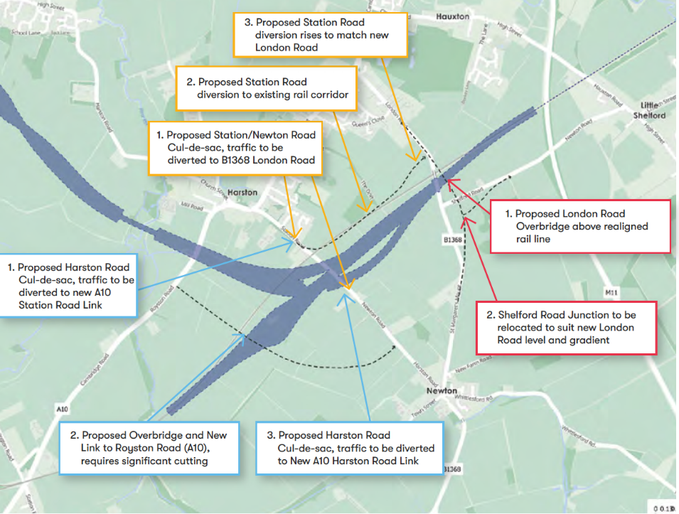

Possible configuration of the line at Harston
Newton Parish Council is opposing the proposal to close off the existing Harston Road.
Land Supply
South Cambs and Cambridge City Councils published their joint updated housing trajectory and five year housing land supply position statement on 19th March 2021.
The updated housing trajectory concluded that Cambridge City and South Cambs jointly have 6.1 years of housing land supply for the 2021-2026 five-year period.
Ministerial Statement on Development on South Cambs.
The following ministerial statement was made on 29th March by Chris Pincher MP, Minister for Housing at MHCLG, in relation to proposed developments in South Cambridgeshire:
“The new town being proposed in South West Cambridgeshire is a private initiative being promoted by the developers Thakeham, and is a matter for the local planning authority. The Government has no plans for an additional new town in this location or elsewhere in South Cambridgeshire beyond the commitment we announced in 2020 to explore opportunities at Cambourne and the sustainable and sensitive expansion of Cambridge. Government has not yet made any decision to take forward opportunities at Cambourne or Cambridge as part of this work and any potential future plans would be subject to all necessary and appropriate public consultation.”
Covid Recovery Grants
South Cambs has launched a £30,000 Covid recovery grant fund to help local community groups and parish councils resume activities following the easing of pandemic restrictions. Grants for up to £2,000 will be available to applicants in respect of covid related recovery projects.
The Council has earmarked the financial package as part of its Community Chest funding so that community groups and parish councils can progress projects and services that will support local people.
The usual funding rules have been relaxed so that Community Chest funding will be open to all parish councils and community groups – including new ones that are now setting up. Applications are now being accepted until 10 May 2021.
Extended Retail Hours
The Government has asked local planning authorities to permit non-essential retailers to extend their daily opening hours from 7am to 10pm, Monday to Saturday, to ensure there is a safe retail environment when non-essential shops reopen from 12 April.
Extended retail opening hours will be possible, from Step 2 of the roadmap (no earlier than 12 April) until the introduction of Step 4 of the roadmap (scheduled for no earlier than 21 June 2021). Planning enforcement will not operate in relation to extended non-essential retail opening hours between 7am to 10am, Monday to Saturday, during this time
Cllr Richard Williams
Cllr.williamsR@scambs.gov.uk

Report for Parish Councils – April 2021.
Cambridgeshire County Report
Vaccination
You can see the daily data here:
https://www.england.nhs.uk/statistics/statistical-work-areas/covid-19-vaccinations/
Foxton Travel Hub
Myself, Foxton & Fowlmere Parishes had a call with GCP on the hub on March 18th Still a long way to go !
East West Rail
You will have seen the consultation initiated for EWR which has most relevance for Foxton & Shepreth but mostly for Haslingfield/Hauxton.
A505 Traffic
I asked for the traffic numbers/peak time profiles – this is the November 2019/2020 snapshot:
A505 Dottrell Hall |  |  | A505 Duxford
 | 5day Average |  |  | 5day Average
 | Nov-19 | Nov-20 |  | Nov-19 | Nov-20
Top of Form  12H(7-19)  Bottom of Form | 8837 | 5449 |  | 27071 | 19009
16H(6-22) | 10045 | 6195 |  | 31838 | 21455
18H(6-24) | 10228 | 6285 |  | 32862 | 21919
24H(0-24) | 10636 | 6619 |  | 34773 | 22934
Peaks
AM Peak | 08:00 | 07:00 |  | 08:00 | 07:00
 | 885 | 679 |  | 2737 | 2096
PM Peak | 17:00 | 16:00 |  | 17:00 | 16:00
 | 1046 | 580 |  | 2613 | 1979

Childcare for 2 Year Olds
What is the entitlement?
Children are entitled to 570 hours in each 12 month period from the term they become eligible until they reach compulsory school age, the term following their fifth birthday. The hours you take up are spread evenly over the year and can be taken as a maximum of 15 hours a week over up to 38 weeks in a year or stretched with fewer hours a week over more weeks in a year.
The hours and sessions which are available for free childcare will depend on the individual childcare setting and will need to be agreed in advance. There should not be any additional costs attached to claiming the free hours, such as top up fees or uniform charges. If you need further advice please contact our Family and Childcare Information helpline on 0345 045 1360.
What are the benefits for my child?
Children benefit from early learning, we know this from research. Good quality early learning:
- helps your child to be happy, confident, sociable and curious
- gives opportunities to be active and learn through fun and play, indoors and outdoors
- offers many activities including creative and messy play
- helps them to become effective learners and ready for school
- has a long term impact on their development

Eligibility: Either parent must be in receipt of one of the following benefits:
- Working Tax Credit provided your annual income (as assessed by HM Revenue & Customs) does not exceed £16,190
- Income Support
- Income Based Job Seekers Allowance
- Income-related Employment and Support Allowance
- Support under part VI of the Immigration & Asylum Act 1999
- Child Tax Credit provided your annual income (as assessed by HM Revenue & Customs) does not exceed £16,190
- Guarantee element of State Pension Credit
- Universal Credit (provided you have an annual net earned income of no more than £15,400, as assessed by earnings from up to three of your most recent assessment periods)
Or, the child:
- has been adopted from local authority care
- has been looked after by a local authority
- has left care through a special guardianship or child arrangements order
- is in receipt of Disability Living Allowance
- has an Education, Health and Care (EHC) Plan
Thakeham
We held a Parish Call on March 20th with Anthony Browne and a Public Call April 7th to update on progress and next steps for the action group.
Updates as usual here: www.swcag.org.uk

Peter McDonald
April 6th 2021

ITEM 10. ACCOUNTS
Month 1 Accounts 2021/22
1st April 2021 – 13th April 2021

ACCOUNTS TO PAY
Peoples Pension (Employers Contribution) 91.91
Peoples Pension (Employees Contribution) 56.99
Barclays Banking Charges 14.30
Parish Cemetery 140.00 Chq 100334
Maynards Open Space 140.00 Chq 100335
Allotments & Community Orchard 160.00 Chq 100336
Clerks Salary (72 hours) 1,115.74 Chq 100337
Clerks Paye to HMRC 126.80 Chq 100338
NP Admin 88.73 Chq 100339
Simpsons Nurseries (Tree Group) (Vat - £5.66) 33.98 Chq 100340
Community Fund (Reclaim accounts paid) 200.00 Chq 100341
Cambridge Water (Allotments) 42.62 Chq 100342
Cambridge Water (Parish Cemetery) 35.61 Chq 100343
TOTAL ACCOUNTS TO PAY £2,246.68
VAT FOR MONTH 1 £5.66

ACCOUNTS RECEIVED
Farm Rent – A Arbon 127.50
Farm Rent – J Jennings 193.75
Donation to Community Fund 100.00
TOTAL ACCOUNTS RECEIVED £421.25
COMMUNITY FUND EXPENDITURE REPORT

Balance carried forward to 1st April 2021 £1,431.65
Accounts paid 13th April 2021 200.00
Accounts received 13th April 2021 100.00
AVAILABLE BALANCE £1,331.65

ZERO CARBON GRANT EXPENDITURE REPORT

Balance carried forward to 1st April 2021 £2,115.70
Accounts paid 13th April 2021 33.98
AVAILABLE BALANCE £2,081.72

ITEM 11. CORRESPONDENCE
The Parish Clerk had been contacted in relation to parking notices left on commuter vehicles at both Station and Royston Road.
Following a public meeting on 2020, Cambridgeshire Police were hoping to work with the residents asking them to join a group by signing up to a scheme where you can offer space on your driveway to a commuter for a small fee.
It was hoped it would reduce the parked cars and to minimise them being targeted when left on a residential street for many hours of the day.
Further discussion is required so that all residents are fully aware of how the scheme works and who to get in touch with.

ITEM 12. DATE OF NEXT MEETING – Tuesday 4th May 2021 followed by the Annual Parish Meeting on Wednesday 5th May 2021.

