WHITTLESFORD PARISH COUNCIL
MINUTES
OF PARISH COUNCIL MEETING HELD ON TUESDAY 12TH JANUARY 2021

Two applications were received for the position of councillor and prior to the start of the meeting all councillors present voted. Philip James was co-opted with 6 votes to 3.
PRESENT
Chairman Arthur Greaves, Pam Freeman, Ken Winterbottom, Tim Teversham, Jan Holmes, Will Thomas, Felicity de Vries, Michael Kilpatrick, District Councillor Richard Williams, County Councillor Peter McDonald, Parish Clerk Marie Swann, Philip James and 5 members of the public.
ITEM 1. APOLOGIES FOR ABSENCE
Apologies were received from Ken Macdonald.
ITEM 2. DECLARATION OF INTEREST
None
ITEM 3. SIGNING OF THE MINUTES
The minutes of parish council meeting of 8th December were signed as a true record.
ITEM 4. MATTERS ARISING
Following on from the discussion to retender the maintenance contracts, an advert will be placed in the February edition of LOOK inviting existing contractors and anyone else wishing to apply. The closing date will be 1st March. All Contracts will begin on 5th April.
We have been invited to present our LHI bid to highways. Councillor Kilpatrick will be representing our parish in a bid to have a small stretch of footpath installed from the new development at Moorfield Road that connects the existing footpath.
Chairman raised a matter with CAPALC to check that backdated expenses can be paid to the clerk as a contribution towards providing telephone and broadband from November 2019 to November 2020. It was agreed to pay a contribution of £50 per month. The total of £600 will be paid in Februarys accounts.
ITEM 5. OPEN FORUM
The current condition of the Baulks footpath was raised by a resident.
Councillor Peter McDonald to follow this up with the County Council.
Graffiti was reported on several litter bins along Duxford Road. Clerk to action this (if contractors are currently working despite lockdown).
An increase of litter has been reported on the verges throughout the village.
Several residents have been litter picking whilst out walking.
A Street light in West End that was previously reported with a fault is still out of action. Clerk to follow this up as residents concerns of how dark it is without a working light. Also to establish if this particular light will be replaced with the new style LED lamp.
The Village Shop & Post Office have reduced the opening hours.
The Shop is now open from 8am – 2pm (Monday – Friday) 8am – 12 Noon (Saturday & Sunday) The Post Office hours are now 9am – 12.30pm (Monday to Saturday) The Post Office is NO longer a collection point for Repeat Prescriptions. The Granta Medical Practice has written to residents advising them of a home delivery service. More information can be found on the medical practice website : www.grantamedicalpractices.co.uk

ITEM 6. UPDATE ON DATA AND POSITIONING OF SPEED MONITORS
Three new traffic speed monitors were installed in December at Duxford, North and Hill Farm Road. Councillor Kilpatrick has taken on the role to monitor the data we receive from the monitors on traffic movements.
It is intended to give a quarterly report, however early indications show that some tweaks are required to make sure they are set up correctly in order to receive the best results.
It was reported that the monitor in Hill Farm Road requires an additional pole to be installed that is within the 40mph speed limit.
The monitor at North Road perhaps should be moved further back in order to slow down traffic movements that come into the village from the Shelford Road. This monitor could be shared with Newton Road which is another hotspot. An additional post would also be required to house the monitor at Newton Road. Much discussion on the location of the Duxford Road monitor, but it does appear to be making a difference.
ITEM 7. FOOTPATH DISCUSSION
Councillor Kilpatrick raised the matter of footpaths now that more and more people are out and about walking and taking regular exercise throughout lockdown. Do we have enough footpaths ? Could and should we raise the matter with local land owners ? to see if other areas might be considered for public access ? This matter requires further discussion and it was agreed to have it as an agenda item later into the new year. Councillor Kilpatrick to establish land and ownership within the village where this might be possible.

ITEM 8. PLANNING REPORT
Planning Ref : 20/04933 – Aerodrome Service Station – Demolition of existing forecourt and the construction of a new forecourt and sales building was not supported by the parish council.
(Re submission of planning ref : 20/02063)
Planning Ref : 20/05164/HFUL – 28 West End - Roof extension of detached chalet bungalow to convert into a two storey house, which includes a two storey side extension and new porch. (Re submission of previous application 20/03533/HFUL) was not supported by the parish council.

ITEM 9. COUNTY & DISTRICT REPORTS

Report for Parish Councils – January 2021.
Cambridgeshire County Report
C19 Case Numbers Cambridgeshire
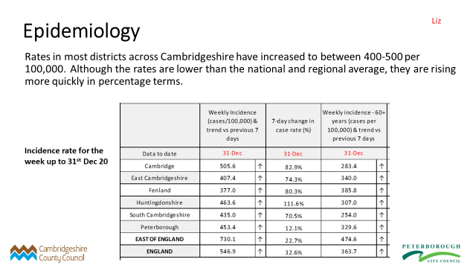
Vaccination I think you all know the vaccination hierarchy but here it is anyway. Granta Medical Practise will be starting Cat 1 & 2 Jan 15th. 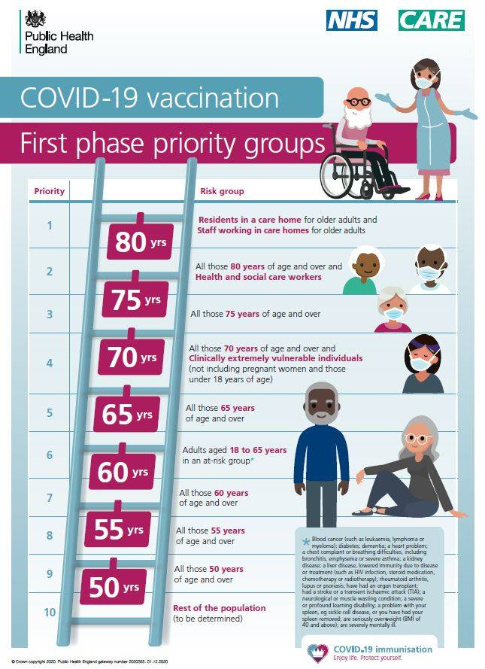
Summary of County Council Services Opened & Closed
Coroners - The Coroners service for Cambridgeshire and Peterborough is continuing to operate as normal. Inquests are continuing to be held remotely (via Skype) and in person. It is recommended that people attend inquests remotely where possible.
For more information on the service including contact details and forthcoming inquests visit here
Household Recycling Centre – All nine HRCs in Cambridgeshire will remain open as usual during lockdown with safety measures in place, however customers are advised to avoid unnecessary visits.
For more information, including opening hours and booking timeslots visit here
Libraries – All libraries in Cambridgeshire are open, with safety measures in place but operating a restricted service. Customers can use the Select and Collect service to choose and pick up titles, as well as using computers by appointment, with bookings limited to those using public services only. For more information about library services and opening hours visit here
Registration Services - Following the lockdown announcement, marriage and civil partnership ceremonies can only take place in exceptional circumstances (such as one party with a terminal illness meaning very short life expectancy) and both council’s registrations teams are in the process of contacting all couples with a ceremony booked in January and February to discuss options.
In Cambridgeshire, the county’s registration service is open for certain pre-booked appointments only:
- Deaths that took place in Cambridgeshire (these are conducted by telephone)
- Births that took place in Cambridgeshire
- Notices of marriage or civil partnership (ceremony must be booked first – these can be booked for late Spring onwards)
- Citizenship ceremonies
Copy certificates, for events previously registered, can be ordered online.
For full details about Cambridgeshire registration services and / or to book visit here. If you are unable to book / order on-line then please call 0345 045 1363.
Residents can continue to register births, but there may be a longer wait than usual for an appointment. Death registrations take place over the telephone, you can book an appointment by calling the office or online.
For notice of marriage/civil partnership appointments – customers with booked appointments during lockdown can still attend. The team is contacting, in ceremony date order, those couples who need to give their notice of intention.
Citizenship Ceremonies - Small group citizenship ceremonies are being held. To book a place call 01733 864646.
Certificates - Orders can only be taken for certificates from recently registered births and deaths. The priority service is suspended.
Clinically extremely vulnerable urged to shield and seek support if they need it - Residents across Cambridgeshire and Peterborough who have been identified by the NHS as clinically extremely vulnerable are being urged to shield once again, following the announcement by the Prime Minister of a further national lockdown.
You can read the full guidance on shielding on the government website, visit https://www.gov.uk/government/publications/guidance-on-shielding-and-protecting-extremely-vulnerable-persons-from-covid-19
If you have previously registered or have already secured priority supermarket delivery slots, you don’t need to re-register. But if you haven’t already done so, you can register online today. To access the registration service, go to https://www.gov.uk/coronavirus-shielding-support
Contact details for the local support hubs are as follows:
- If you live in the South Cambridgeshire District Council area: www.cambridgeshire.gov.uk/coronavirus or 0345 045 5219
If you are not sure which is your local hub, contact the countywide coordination hub via www.cambridgeshire.gov.uk/coronavirus or call 0345 045 5219.
The national NHS Volunteer Responders service is also still available, and support can be accessed via https://nhsvolunteerresponders.org.uk/services, or by calling 0808 196 3646 (8am to 8pm, 7 days a week).

Peter McDonald
January 10th 2021.

District Report - January 2021 – Councillor Richard Williams
Unsurprisingly, it has been a quiet period at South Cambs over Christmas
COVID GRANTS
The Council will be administering the latest batch of covid grants for businesses arising from the latest lockdown and announcement by the Chancellor. Specific details are not available yet, but I expect the grants to be similar to those in the November lockdown which I gave details of in my last report but one. As ever, information will be published on the South Cambs website:
https://www.scambs.gov.uk/coronavirus/

BUDGET
The draft 2021-2022 budget for the Council was released today (12/01/21). I have not yet had time to scrutinise the detail and will update the Council next month on ant relevant matters.

PARKING ENFORCEMENT
I was informed just before Christmas that the issue of civil parking enforcement is to be discussed by the Greater Cambridge Partnership, probably in March, and some proposals will be put forward.
PLANNING
As members know, a new application has been made in respect of the garage near Burma Road. I have liaised with planning about this and the likely resubmission of the Scrap Yard application. There are no new developments on the local plan to note but I expect some more information shortly on the preferred route for the East-West Rail line.

The proposal by Thakeham for a huge ‘new town’, though not directly affecting us, is obviously a concern. As members will have seen, the proposal is to be submitted as a late entry in the call for sites.

ITEM 10. ACCOUNTS

The following accounts were approved.
Month 10 – 9th December 2020 – 12th January 2021
ACCOUNTS TO PAY
Parish Cemetery 140.00
Maynards Open Space 140.00 Chq 100317
Allotments & Community Orchard 160.00 Chq 100316
Peoples Pension (Employers Contribution) 102.15
Peoples Pension (Employees Contribution) 63.84
Barclays Banking Charges 18.95
Clerks Sationery items purchased 28.73
Haven Power (Street Lighting) 239.46 (Vat - £38.26)
One.Com (NP Website Subscription) 49.72 (Vat - £8.29)
NP Admin 80.51 Chq 100313
Clerks Salary (56 hours plus holiday pay) 1,221.48 Chq 100314
Clerks Paye to HMRC 170.16 Chq 100315
TOTAL ACCOUNTS TO PAY £2,415.00

ACCOUNTS RECEIVED
UK Power Networks (Sub Station Rent) £376.79

COMMUNITY FUND EXPENDITURE MONTHLY REPORT
Opening Balance £3,562.00
Balance at last meeting (8th December) £2,102.45
ACCOUNTS RECEIVED (9th December – 12th January) -----------
ACCOUNTS PAID (9th December – 12th January) £207.80
TOTAL EXPENDITURE TO DATE £1,667.35
AVAILABLE BALANCE OF COMMUNITY FUND £1,894.65

ZERO CARBON GRANT EXPENDITURE MONTLY REPORT
Opening Balance £3,611.00
Balance at last meeting (8th December) £2,765.70

Last paid accounts (8th December) £45.04
No accounts paid (12th January) -------
TOTAL EXPENDITURE TO DATE £845.30
AVAILABLE BALANCE OF ZERO CARBON GRANT £2,765.70

ITEM 11. CORRESPONDENCE
Chairman received an email in relation to litter at Hill Farm Road.
It was agreed we would monitor the situation.

ITEM 12. DATE OF NEXT MEETING (Tuesday 9th February 2021)

