WHITTLESFORD PARISH COUNCIL
MINUTES
OF MEETING HELD ON TUESDAY 9th FEBRUARY 2021

PRESENT
Chairman Arthur Greaves, Tim Teversham, Ken Winterbottom, Pam Freeman, Will Thomas, Jan Holmes, Michael Kilpatrick, Ken Macdonald, Felicity de Vries, Philip James, District Councillor Richard Williams, County Councillor Peter McDonald, Parish Clerk Marie Swann and 2 members of the public.
ITEM 1. APOLOGIES FOR ABSENCE
None
ITEM 2. DECLARATION OF INTEREST
None
ITEM3. SIGNING OF THE MINUTES
The minutes of meeting of 12th January were signed as a true record.
ITEM 4. MATTERS ARISING
Having looked into the current rent of farm tenancies, the chairman proposed that no changes be made to the current tenancies until further investigation. There is no agreement in place to say that the rents should be reviewed other than the previous 5 year plan drawn up by the previous clerk which expired in November 2020. It was therefore agreed to put it on hold until the finance meeting in November 2021.
ITEM 5. OPEN FORUM
Vandalism to the Shelford Road boundary sign and the 40mph speed roundel was reported. The incident has been reported to highways who will cost and replace the items. It was requested that upon installation the posts be moved over slightly into the grass verge as the previous Whittlesford boundary sign was often clipped when large and wider vehicles passed as it was possibly too close to the edge of the road. Also a tree trunk is currently leaning and requires cutting back before the speed roundel is re attached.
ITEM 6. CALL FOR SITES
Following a recent Neighbourhood Plan meeting both Chairman and Councillor Richard Williams gave an update on what the group had discussed and whether or not the plan should be proactive in identifying possible Green Belt. If it was likely that some would be required or whether this would be ‘opening the door’.
Councillor Richard Williams advised it would be better at this point not to put Green Belt land forward, and in any case it would not be passed by the inspector. It would be important to ensure the policies were robust enough to rule out potential places eg through protected views.
It was noted that ‘’more stringent development controls’’ doesn’t mean ‘protected’ and that certain possible sites which were important wildlife sites need to be opposed.
Chairman asked all councillors for their comments to reach Ken Winterbottom by the 23rd February in order for the parish council to put forward their report.
There will be a further consultation later on in the year which will give the public an opportunity to put forward their comments.

ITEM 7. CHAIRMANS UPDATE ON THE NEIGHBOURHOOD PLAN
Chairman also gave a further update on where the plan is at and how to move forward. Councillor Richard Williams had looked at the plan and suggested looking at Cottenham and Foxton to compare and see how the group could get their plan into the same kind of cohesive format. Councillor Williams felt the plan needed a good amount of sharpening to get it in order, especially around the language in the policies. The group could do this and then get a professional to focus on the really fine detail.
Having been asked what is happening with the plan, it was noted the importance of getting it finished and start to engage with the village again.
The group also discussed what may happen around the travel hub and whether it would still be viable with the ‘working from home’ situation.

ITEM 8. PLANNING REPORT
Planning Ref : 20/05272/HFUL – Scotts High Street – Installation of Outdoor Swimming Pool and Timber shed.
The Parish Council made a No Recommendation on the one planning application received for an outdoor swimming pool. Concerns were expressed because no information was supplied as to the noise levels likely to be generated by the Air Source Heat Pump which will be used to provide heat for the pool, or for the hours which it will operate. If the pump is to operate on a 24/7 basis any planning permission consent should be conditional on night time noise levels below specified values as determined by the Environmental Control Department of the South Cambs District Council.

ITEM 9. COUNTY & DISTRICT REPORTS

Report for Parish Councils – February 2021.
Cambridgeshire County Report – Peter McDonald
C19 Case Numbers Cambridgeshire
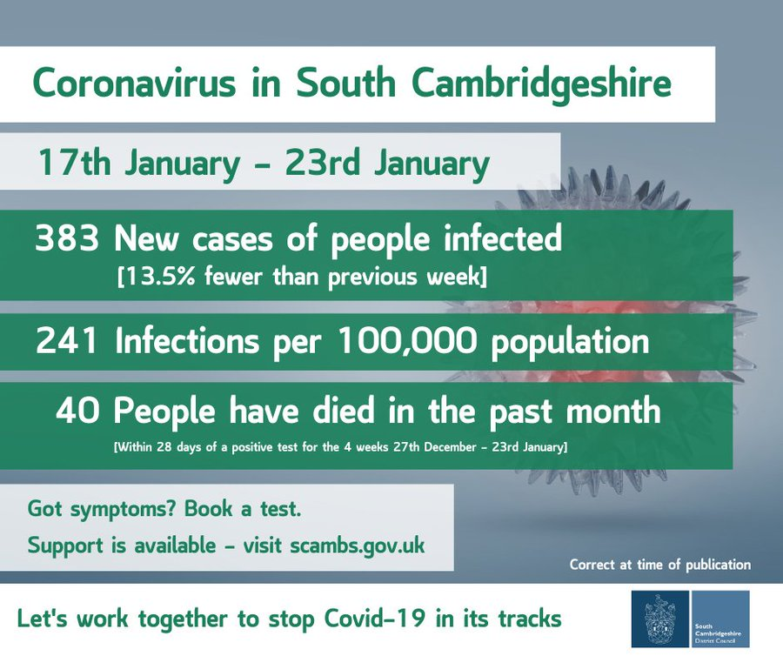
Vaccination Here is the status as of Jan 28th on vaccination which shows 81% of > 80’s receiving first dose in Cambs/Peterborough.
You can see the daily data here:
https://www.england.nhs.uk/statistics/statistical-work-areas/covid-19-vaccinations/

Rapid Testing for Key Workers or Unable to Work from Home
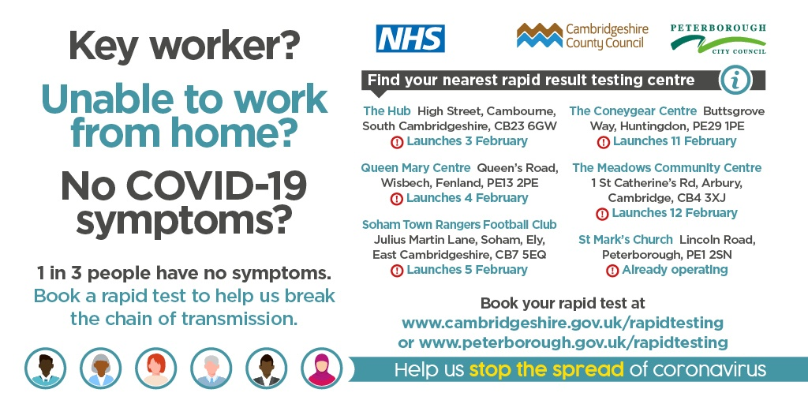

Rapid testing for key workers and all those who cannot work from home is set to launch across Cambridgeshire and Peterborough from this weekend to help track cases of Coronavirus and drive down transmission rates.
A number of sites are being set up across the county offering rapid tests to people aged 18 and over who have no symptoms of Coronavirus. It follows a commitment from the Government to test as many people who are key workers and/or cannot work from home as possible.
Cambridgeshire County Council and Peterborough City Council have been allocated 100,000 tests in the next six weeks, with the potential for the pilot to be extended.
Around one in three people who are infected with Covid-19 have no symptoms and could be spreading the disease without knowing it. Broadening testing to identify key workers showing no symptoms will mean finding positive cases more quickly, which helps break chains of transmission.
Initially there will be six sites across the county, with the potential to set up pop-up sites in areas of high need if required. Tests will be offered at no cost to the public.
Tests will be available in the following locations:
- Cambridge, The Meadows Community Centre, 1 St Catherine’s Rd, Arbury, Cambridge, CB4 3XJ – launches Friday 12 February.
Each site will be open 8am to 8pm, Monday to Saturday, apart from the Peterborough site which is open every day from 9am to 2pm and 4pm to 7pm.
To book a test, people need to visit the Cambridgeshire County Council website
Lateral flow tests are a new kind of technology that can be used to test a higher proportion of asymptomatic people and do not require a laboratory to process the test.
The process of taking a test takes on average 15 minutes from arrival to departure.
People with symptoms will not be tested at the rapid testing sites. Anyone with one or more of these Coronavirus symptoms – a high temperature, a new, continuous cough, or a loss or change to sense of smell or taste – should book a test at nhs.uk/coronavirus or by calling 119.
Foxton Travel Hub
I chaired a meeting between Foxton & Fowlmere PC’s, Neil Gough (S Cambs GCP Board Member) and officers from GCP. I think it was productive - next steps are a full engagement with officers.
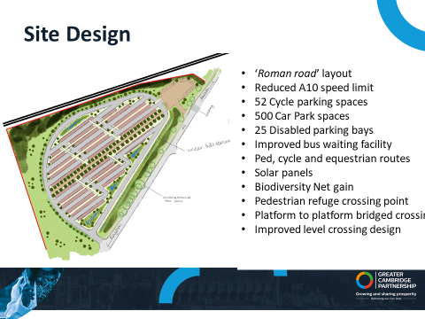

Thakeham Development
We (the action group) held an open meeting with 70 attendees on Jan 20th. The presentation is here:
https://17a4c9c5-bc96-42ff-89cb-56a5069d86b6.filesusr.com/ugd/11c8bf_ccf8e8132aae4c47b861942733784a5c.pdf
The FAQ’s from that meeting is here
https://17a4c9c5-bc96-42ff-89cb-56a5069d86b6.filesusr.com/ugd/11c8bf_1806f3efe8ab4a09a238f06872977f67.pdf
Subequently we had a response to our FoI to the Ministry where they refused information as it was “not in the public interest “!
https://17a4c9c5-bc96-42ff-89cb-56a5069d86b6.filesusr.com/ugd/11c8bf_045cc92024c84bcd8a2d1f3d1f31ae44.pdf

District Report February 2021
Local Plan
The District Council has contacted Parish Councils to offer the opportunity to comment on sites put forward in the call for sites. Parishes can comment on individual sites under a number of different headings covering transport, environmental and historical considerations, utilities, impact on area, utilities etc. The opportunity to comment on sites will be discussed by the Parish Council at this meeting and it is important that we provide robust feedback to the District Council. Parish feedback will form part of the evidence base for selecting preferred sites, which should happen later in the year. Responses must be submitted by 1st March 2021.
Doubling Nature Strategy.
The Council has approved a new ‘doubling nature’ strategy. The strategy, which is high level rather than site specific, aims to increase wildlife-rich habitats, the tree canopy and improve access to green spaces across the district. Key objectives for the strategy are:
- Giving nature space and help to reverse declines in habitat and species;
- Providing more areas for people to enjoy nature and benefit their health & wellbeing;
- Improving the quality of air;
- Helping to manage water for nature;
- Creating more resilience to climate change;
- Boosting the economy of the district.
Calk Streams Report: Opportunity to Comment.
South Cambs DC along with Cambridge CC is inviting residents to comment on a draft report on the health of the District’s chalk steams. Increasing abstraction of water from the Cambridge aquifer resulting from a continued high pace of development in South Cambs, alongside dry winters, is putting pressure on our chalk streams. Our chalk streams are recognised as internationally rare habitats providing homes for many significant species, including brown trout and water vole.
The chalk streams report is an in-depth audit of the 17 chalk streams in our area and identifies a number of challenges, including flow pressures, channel modification and poor water quality. The report is one of a series of studies that will look at the present and future demands on watercourses and water supply in the area and will feed into the next Local Plan. The opportunity to comment on the report is open until 4th March 2021. The report and details of how to submit comments can be found here:

https://www.cambridge.gov.uk/chalk-streams

Draft Budget 2021/22
The draft South Cambs Budget for 2021/22 will be considered by the full Council on 23rd February 2021. The headline objectives of the budget are to continue to support residents and businesses through the pandemic and to invest in digital services to improve ‘customer service’. A Council Tax rise for the District of £50 per year for a Band D property is proposed.
Waterbeach New Town
As you may have read in the press, the District Council has granted outline planning permission for the second half of Waterbeach New Town. Outline permission for 11,000 new homes has been granted between the two parts of the development which notably exceeds the 8,000-9,000 homes envisaged in the 2018 Local Plan. The proposed average density of the new settlement, at 45 homes per hectare (hph), also exceeds the Local Plan guide of 40 hph. In some parts of the new settlement outline permission has been granted for a density of 100 hph. The District Council’s approval of the application came despite objections from the local Parish Council and the County Council transport team.
Affordable Homes and Homes for Rent Consultation.
South Cambs and Cambridge City are inviting residents to share their views on three new policies concerning affordable homes and homes built for rent.
The new policies will cover:
- Where on a new development new affordable homes (such as rental social housing and shared ownership homes) should be situated. The policy will cover the size of affordable homes clusters; how to ensure different sizes of homes are mixed together (where appropriate); and making sure affordable housing is well mixed with market housing.
- How the councils set rent levels for social housing to ensure that they are as affordable as possible to applicants on the councils’ housing registers.
- The development of homes built specifically to be rented out i.e. Build to Rent, looking at what the councils expect in terms of issues such as size and layout; quality of design and management; and how schemes should contribute to providing affordable housing.
The policies will form part of the Greater Cambridge Housing Strategy 2019-2023, and are primarily aimed at new housing developments across both Cambridge and South Cambridgeshire. The policies will also inform the development of the Local Plan.
The consultation is open until 23 March 2021 and can be found here (with supporting documents):
https://www.scambs.gov.uk/Housingpoliciesconsultation2021
Cllr Richard Williams
Cllr.williamsR@scambs.gov.uk

ITEM 10. ACCOUNTS
WHITTLESFORD PARISH COUNCIL
(Month 11 Accounts - 13th January 2021 – 9th February 2021)

ACCOUNTS TO PAY
Parish Cemetery 140.00
Maynards Open Space 140.00 Chq 100318
Allotments & Community Orchard 160.00 Chq 100319
Peoples Pension (Employers Contribution) 81.05
Peoples Pension (Employees Contribution) 50.66
Barclays Banking Charges 14.60
Haven Power (Street Lighting) (Vat - £39.68) 247.86
Clerks Salary (60 hours plus 1 day bank holiday) 1,034.63 Chq 100320/21
Clerks Paye to HMRC 70.12 Chq 100322
Clerks expenses (Telephone & Broadband) 600.00 Chq 100323
Cambridgeshire Acre Subscription 57.00 Chq 100324
King & Co (The Tree Nursery) (Vat - £108.33) 650.00 Chq 100325

TOTAL ACCOUNTS TO PAY £3,245.92
VAT FOR MONTH 12 £148.01

NO ACCOUNTS RECEIVED

COMMUNITY FUND EXPENDITURE MONTHLY REPORT
Opening Balance £3,562.00
Balance at last meeting (12th January) £2,102.45
Last paid accounts (12th January) £207.00
Accounts received (12th January – 9th February) -----------
Accounts to pay (12th January – 9th February) £100.00
TOTAL EXPENDITURE TO DATE £1,767.35
AVAILABLE BALANCE OF COMMUNITY FUND £1,794.65

ZERO CARBON GRANT EXPENDITURE MONTLY REPORT
Opening Balance £3,611.00
Balance at last meeting (8th December) £2,765.70
Last paid accounts (8th December) £45.04
No accounts paid (12th January) -------
Accounts to pay (9th February) £650.00 Chq 100325
TOTAL EXPENDITURE TO DATE £1,495.30
AVAILABLE BALANCE OF ZERO CARBON GRANT £2,115.70

ITEM 11. CORRESPONDENCE
Correspondence received from residents in relation to footpaths and open spaces to be collaborated and discussed further.
ITEM 12. DATE OF NEXT MEETING
Tuesday 9th March 2021

CALL FOR SITES MAP

